***CARGO HOLDS AND HATCHES***

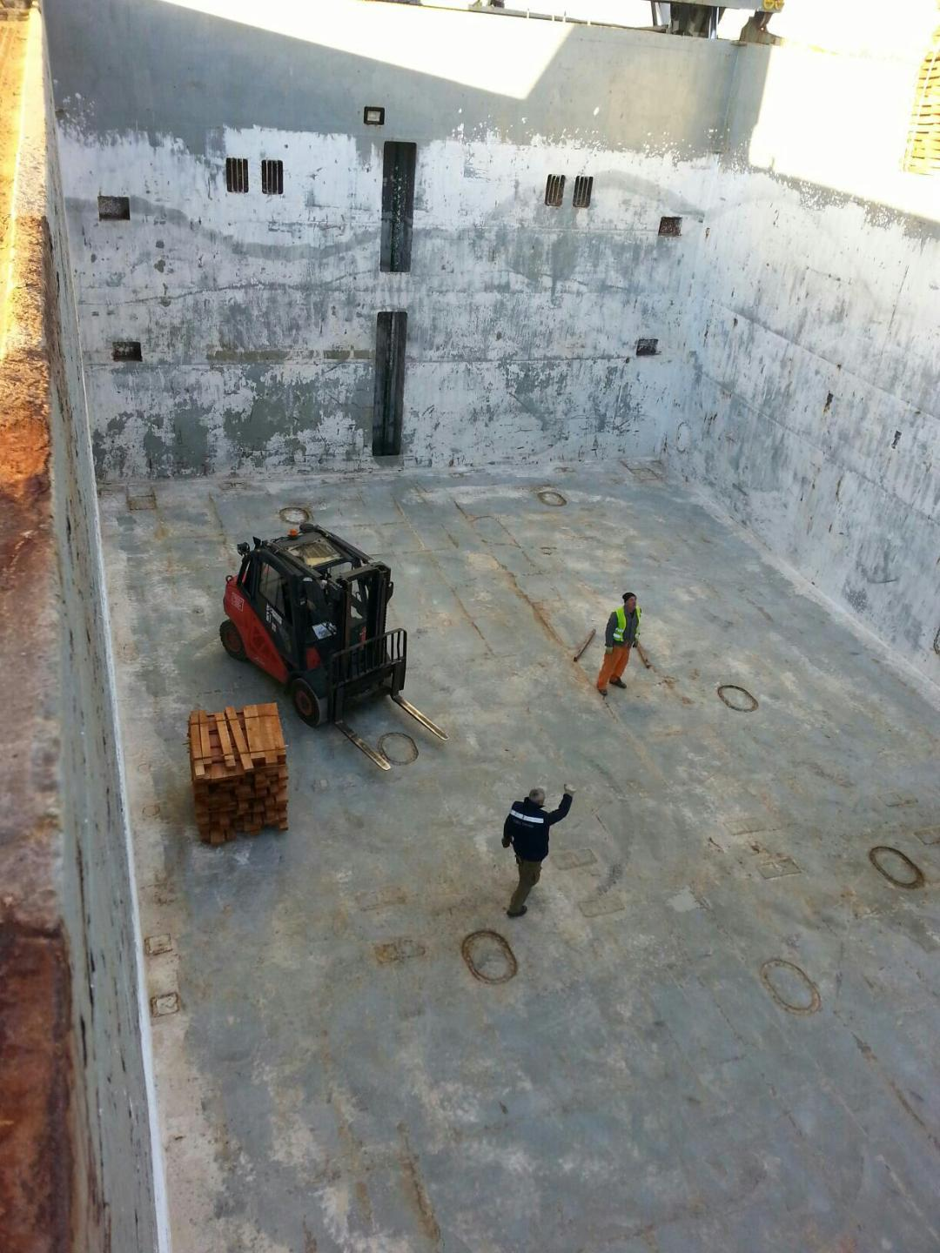

***BOX SHAPED CARGO HOLD***

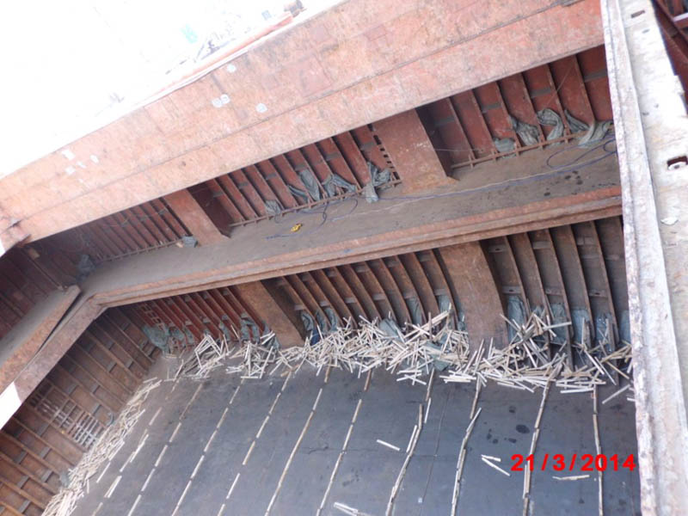

***CARGO HOLD OF TWEENDECKER JUST DISCHARGED (UNCLEANED FOR NEXT CARGO)***

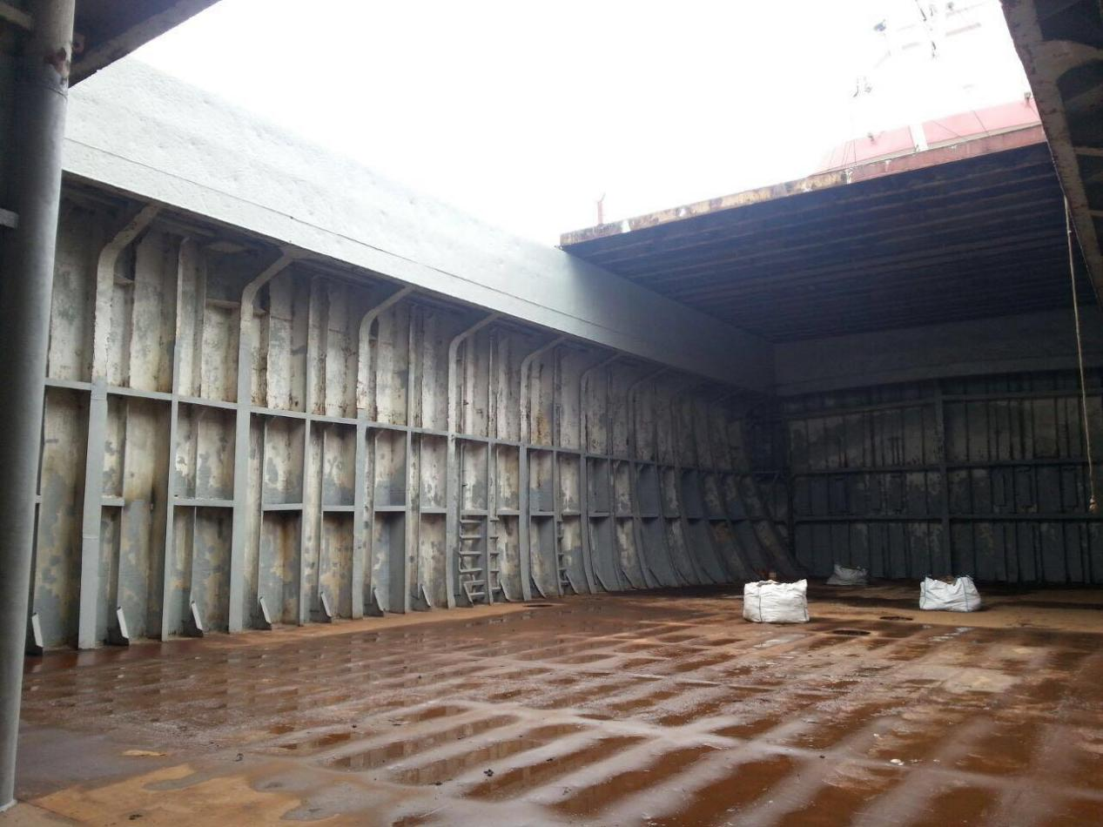

***CARGO HOLD OF A SINGLE DECKER - FRAMES ARE VISIBLE***



***FOLDING TYPE HATCH COVERS***

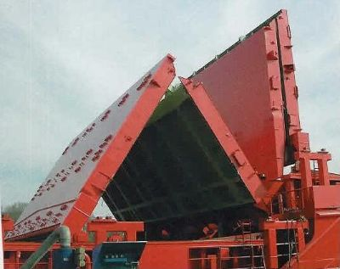

***FOLDING TYPE HATCH COVERS***

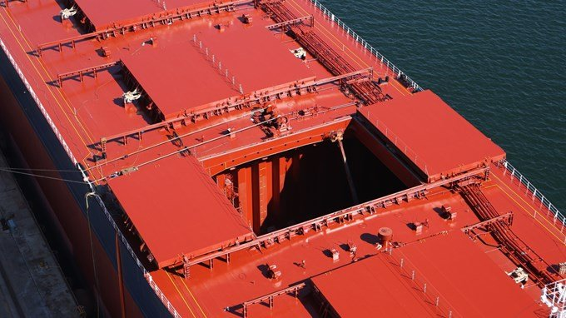

***SIDE-ROLLING TYPE HATCH COVERS***

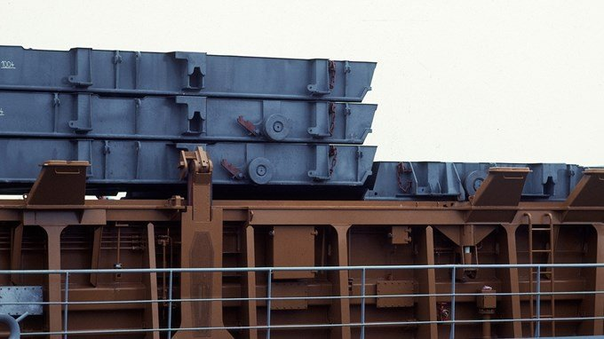

# ***Stacking hatch covers***