Europe’s Dealmakers Top $450 Billion in Rapid Time
M&A values across the region are running at near 20-year highs.
By Fareed Sahloul
May 6, 2026 at 4:00 PM GMT+3
European march
A confession to start—and hopefully my bosses aren’t reading this: it’s been a little hard to concentrate on mergers and acquisitions today.
I’m still on a high from watching my football club Arsenal reach their first Champions League final in 20 years last night. It means the team will have a chance to win European football’s biggest prize in Budapest on May 30; it would be a historic achievement for the club founded around 140 years ago by munitions factory workers.
But amid the lingering euphoria, and trying to figure out the cheapest way to travel to the Hungarian capital at the end of the month, the M&A headlines have kept rolling in as Europe’s dealmakers plot their own path to the history books. Fittingly, you also have go go back around two decades for the last time deal volumes in the region were running this hot.
Let’s take a look at those numbers: the value of M&A involving European companies has risen 39% to more than $455 billion this year, data compiled by Bloomberg show. That really stands out when compared to other major regions. In the Americas, things are running at a far more modest (but still respectable when considering historical averages) 9% higher, and it’s a similar story in Asia Pacific.
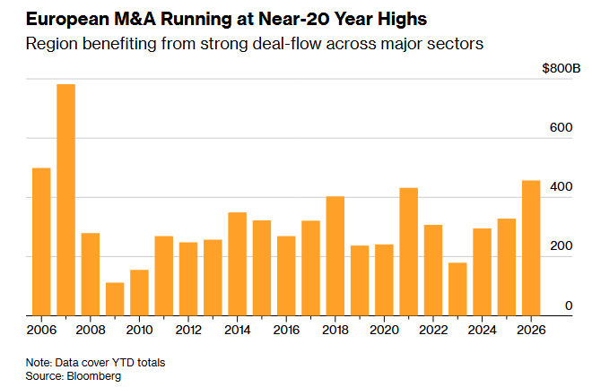
Europe is benefiting from strong deal-flow across a range of sectors, as evidenced by some of the transactions announced in recent days.
On Wednesday, Germany’s Bayer agreed to acquire US eye-medicines maker Perfuse Therapeutics for as much as $2.45 billion, as it looks to strengthen its pipeline amid greater competition for some of its blockbuster drugs. That followed Tuesday’s news that British carrier Vodafone is buying CK Hutchison’s stake in the UK’s largest mobile operator in a deal worth £4.3 billion; and UK testing firm Intertek has received an improved takeover offer from EQT worth almost £9 billion.
What’s really been driving things is a string of $20 billion-plus transactions.
The largest of these saw Unilever agree to merge its food business with spice maker McCormick in a $44.8 billion deal in late March. In the weeks since, Kone has struck a €29 billion takeover of long-term target TK Elevator, and Italy’s UniCredit has taken its roughly €35 billion offer for Commerzbank direct to the German lender’s shareholders (this last one could be hard to pull off).
Tie-ups like Kone-TK Elevator, in particular, speak to a desire among many dealmakers and policymakers to see more European firms emerge with the capacity to compete with US and Chinese rivals. To this end, the European Union recently announced new M&A guidelines—its first major M&A policy overhaul in two decades—aimed at easing the path to such megamergers.
It’s a nice time to be dreaming of European champions, after all. —Fareed Sahloul
M&A focus
Saudi Arabia’s $1 trillion wealth fund started operating a second office in mainland China earlier this year, as part of its efforts to deepen investment ties with the world’s second-largest economy, write Echo Wong and Dinesh Nair.
Elffie Chew, Pei Li and Manuel Baigorri write that Stack Infrastructure, a data center company owned by Blue Owl Capital, is considering options including a sale of its Asia operations. A transaction might be valued at more than $30 billion.
Ametek has agreed to buy a portfolio of instrumentation businesses from Indicor for about $5 billion in cash. The US-based maker of measuring equipment for the aerospace and energy industries plans to fund the transaction via an existing credit facility and new debt issuance
James Murdoch is in advanced talks to acquire New York magazine and a number of podcasts from Vox Media for about $300 million, reports Christopher Palmeri.
Sydney-listed toll road operator Atlas Arteria rejected a takeover bid from its biggest shareholder IFM Investors, saying the $5.3 billion bid was too low.
Global lenders to Sun Pharmaceutical Industries are weighing multiple financing options for its proposed $12 billion acquisition of New York-listed healthcare company Organon, reports Saikat Das.
IPO watch
Wall Street banks are getting ready to raise billions of dollars taking data center companies public, even after IPO investors have already piled into anything that looks like a bet on AI spending.
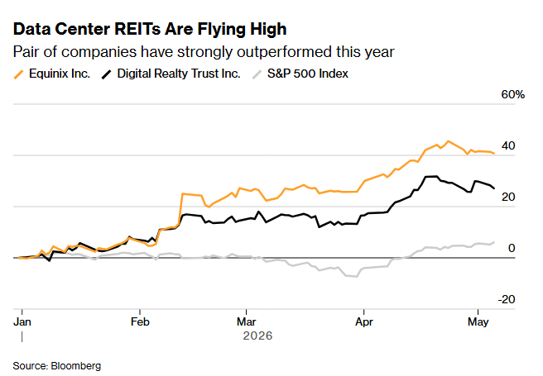
Cerebras Systems is placing limit orders on institutional investors, requiring them to specify the number of shares and the maximum price they’re willing to pay. Anthony Hughes and Bailey Lipschultz report that’s another sign that the AI chipmaker’s IPO shares are in high demand.
Uzbekistan is kicking off a planned series of IPOs with the sale of about a 30% stake in the state investment fund, as part of the Central Asian nation’s push to entice international investors.
Sany Heavy Industry is considering an IPO for one of its units in Hong Kong, write Pei Li and Julia Fioretti. The electric truck maker, Hunan Xingbida Network Technology, could raise about $500 million in an IPO.
Private markets pulse
Blackstone and KKR are in talks with Alphabet to give the companies they own access to Google’s AI models, write Preeti Singh, Dawn Lim and Allison McNeely. The talks come as OpenAI and Anthropic are each partnering with alternative asset managers to form AI consultancies that will turn PE-backed firms into a new revenue source for AI companies.
Who’s news
Goldman Sachs said Stephan Feldgoise and Joshua Schiffrin will join the bank’s management committee, bolstering the firm’s top decision-making group. The bank also named Ericka Leslie as its chief administrative officer.
Bank of America has hired Graziano Gemma from rival Goldman Sachs to be head of its investment banking business in Italy.
And lastly, Morgan Stanley has appointed Alexandre Bartolin and Frederic Proust to co-head France investment banking.
Best of the rest
- EBay can give GameStop $56 billion of bad feedback.
- Flex to spin off cloud and power infrastructure segment.
- EDP weighs sale of US unit focused on small-scale solar power.
- JPMorgan’s top dealmaker says April was ‘challenging’ for M&A.
- New World weighs sale of stake in $2 billion hotel portfolio.
- Mexico’s MIP seeking to invest $12 billion for infrastructure.
- How an 88-Year-old founder clinched a record India finance deal.

