Value of global dealmaking recovers as firms pursue big transactions after Iran war
Published on 04/20/2026 at 04:12 am EDT - Modified on 04/20/2026 at 04:17 am EDT
Reuters
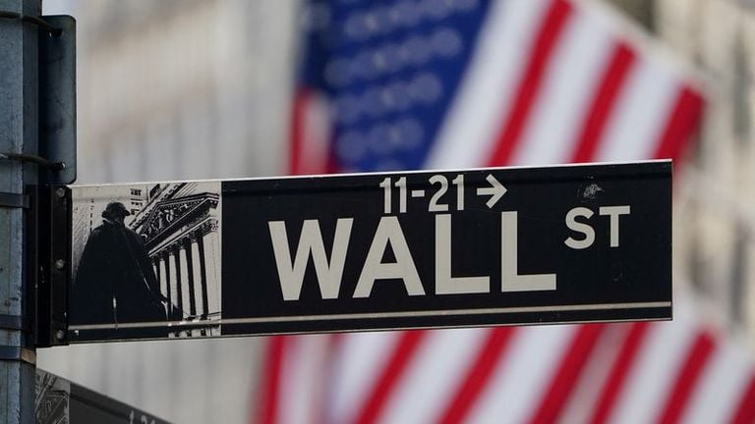
LONDON, April 20 (Reuters) - The value of global dealmaking has rebounded after a sharp slump in the weeks after the start of the war in Iran, as companies and investors shrug off volatility and press ahead with larger deals.
The value of deals announced globally in the second week of March fell to around $39 billion as the U.S. and Israel's strikes on Iran roiled markets. It was the lowest weekly level since the wake of the "Liberation Day" announcement of sweeping U.S. tariffs last April, according to LSEG data.
However, the value of global deals has since rebounded on the back of a series of large transactions, including Pershing Square's $68 billion proposed bid for Universal Music Group and McCormick & Co's $45 billion merger with Unilever's food portfolio.
In the four weeks from March 15, the average weekly value of global mergers and acquisitions rose to around $117 billion, eclipsing the about $93 billion weekly run-rate seen through January and February, according to the data.
"CEO confidence has dropped a bit but the significance and the logic of those corporate transactions remains," said Guillermo Baygual, global co-head of M&A at Citi.
"The geopolitical dynamics, if anything, can add some uncertainty short term but in the long term they justify even more some of these needs to gain scale, to gain cost efficiency and capacity to finance the capex needs that are going to be almost imperative and to deliver further growth."
Some regions have been more affected by the turmoil. M&A involving a target in the Gulf totalled nearly $15 billion so far during 2026, down 65% from last year at this time despite a 5% increase in the number of deal announcements.
LSEG totalled 70 deals were announced in the Gulf in February, a monthly deal count only exceeded once in the region in the last five years. However, in March, after the conflict began, just 37 deals were announced, the lowest monthly total since August 2025.
Gulf entities have been buyers, though. Acquisition values where a Gulf entity is the buyer in mergers and acquisitions was valued at US$17.1 billion in the six weeks since the Iran war began on February 28. That figure is 244% higher than the haul from the six weeks prior to the start of the conflict, but down 21% from the same period in 2025, according to LSEG.
While the number of deals has fallen globally, companies are still pursuing large and transformative transactions.
Smaller deals have fallen in number, potentially impacted by the effects of geopolitics and the macroeconomic backdrop, said Nimesh Khiroya, co-head of M&A in Europe, Middle East and Africa at Goldman Sachs. He suggested the rebound was driven by larger deals already long in the works.
"Large deals would have been in development for a period of time and are not a response to the Middle East conflict," Khiroya added.
The pace of equity capital markets (ECM) dealmaking has slowed after a bumper two weeks immediately after the start of the conflict in which nearly $50 billion worth of transactions were struck globally, LSEG data showed. Global ECM reached $215 billion in the year to April 14, up 37% over the same period last year.
The week immediately after the attacks was the busiest so far this year in terms of capital raised, according to the data, as some firms and their shareholders tapped equity investors before markets potentially soured further and hampered their ability to raise capital, three equity advisers told Reuters previously.
In the four weeks from the 15th of March, the average weekly value of global ECM deals came to around $11 billion, according to the data, down from $13 billion in January and $18 billion in February. Deal value has fallen in part due to a slowdown in new share issuance sparked by the war and a typically quieter period as companies report financial results, one adviser told Reuters.
Market conditions suggest the potential for more dealmaking to return is there. The CBOE Volatility Index, the closely watched gauge of investor anxiety, spiked after the conflict broke out in late February but has since cooled to below 20 in April. The index, often referred to as Wall Street's "fear gauge," is considered to signal stable and less stressful market conditions when it trades below that 20 level, dealmakers say.
"Volatility has affected timing in some cases, but it has not fundamentally altered strategic intent, particularly for large, well-financed transactions," Philipp Beck, EMEA head of M&A at UBS, said.
The long-term impact is yet to be seen after the IMF warned this week that the global economy would teeter on the brink of recession if the conflict worsens.
"If we get into a recessionary environment, people will need to run more scenarios, and that may delay a little bit some transactions," said Baygual at Citi. "But equally, I can see how the next three years are going to be years of very strong activity, as the fundamentals driving M&A since last year remain."
(Reporting by Charlie Conchie and Andres Gonzalez in London; Editing by Anousha Sakoui and Susan Fenton)

© Reuters - 2026

