What Data Tell Us About How M&A Behaves in Times of Conflict
Bloomberg-compiled data show deal numbers tend to fall in the short-term.
By Fareed Sahloul and Alex Dooler
March 2, 2026 at 5:44 PM GMT+2

You’re reading the Bloomberg Deals newsletter.
The latest news and analysis on M&A, IPOs, private equity, startup investing and the dealmakers behind it all, for subscribers only.

Hi, it’s Fareed Sahloul in London and Alex Dooler in Abu Dhabi, with some numbers on how M&A sentiment tends to trend in times of armed conflict. Also today, JPMorgan tests ‘art of the possible’ in LBOs.
Data drop
Geopolitical tension, geopolitical uncertainty and geopolitical conflict—take your pick, these broad terms are often marked in the ‘reasons to be cautious’ column of an M&A cycle. They’ve popped up frequently in recent times given the Russian invasion of Ukraine in 2022, the Oct. 7 attacks on Israel in 2023 and subsequent war in Gaza, and the US bombing of nuclear facilities in Iran in 2025.
You’re likely to start hearing them more in the coming days following the US-Israeli attacks on Iran and the intensifying response from Tehran. For now, the sense among dealmakers seems to be that it’s too early for bold predictions or actions. Spokespeople for firms including KKR, HSBC and Investcorp were reporting business as usual in the Gulf or reaffirming their commitment to the region this morning.
The longer fighting continues, however, the greater the likelihood that this conflict will start to negatively impact sentiment; in a year in which many had been forecasting record levels of M&A activity.
Data compiled by Bloomberg show that the number of announced M&A deals does tend to fall in the six months immediately after a major attack is launched—see chart below. While it’s important to note that in each case there were other factors at play, such as the dotcom crash in the early 2000s and rising interest rates in 2022/2023, history suggests that geopolitics does play its part.
“Recent years have shown that deal requests have slowed down in times of geopolitical crises impacting in Middle East,” said Sorana Parvulescu, partner at strategic intelligence firm Control Risks. “This said, we have seen a very sharp increase of deals in the past 12 months and they are not going to get cancelled overnight.”
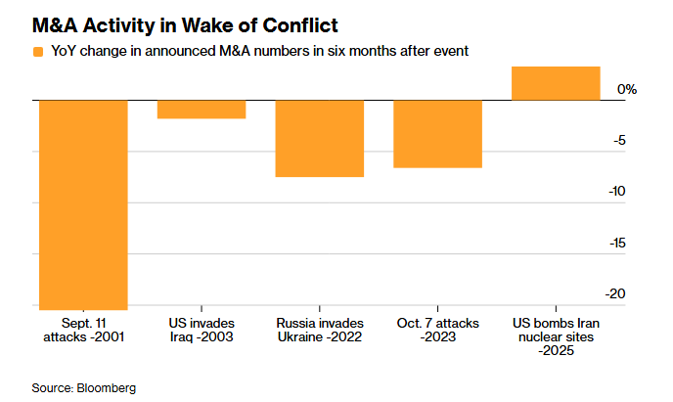
Global stock markets tumbled on Monday as US President Donald Trump said the bombing campaign in Iran could last for weeks. The price of oil jumped with tanker traffic stalled in the Strait of Hormuz. The dollar rallied and gold surged as investors sought havens.
But companies were forging ahead and announcing transactions against this volatile backdrop. Notably, it was Middle East buyers extending a global acquisition spree.
Qatar’s wealth fund is part of a GIP/EQT-led consortium that’s just agreed to buy AES for $10.7 billion in one of the largest US utility deals of recent years. News of that came just hours after Bahraini aluminum producer Alba announced the biggest-ever overseas corporate takeover by a company in the Middle Eastern country.
Outside the Middle East, Magellan Financial Group said it will acquire Australian boutique Barrenjoey Capital Partners for about A$1.6 billion; Warburg Pincus announced an investment of as much as $1 billion in Global Eggs, one of the world’s largest egg producers; and Malibu Boats bought Saxdor Yachts for €150 million. —Fareed Sahloul and Alex Dooler
IPO watch
German defense technology firm Vincorion is set to begin formally marketing its IPO in Frankfurt this week, despite equity markets being roiled by conflict in the Middle East, report Pablo Mayo Cerqueiro and Swetha Gopinath.
Activist corner
The Toyota group reached a landmark deal with Elliott Investment Management to privatize Toyota Industries, paving the way for the biggest-ever acquisition of a Japanese company. The new offer values the company at ¥6.7 trillion ($43 billion).
Private equity pulse
When JPMorgan took the lead last year in financing the $55 billion takeover of Electronic Arts, a record-setting leveraged buyout, Wall Street saw it as a sign that a lucrative period of bankrolling super-sized private equity deals might come roaring back. Aaron Weinman, Rachel Graf and Hannah Levitt report that, five months on, the mood is now less jubilant.
Charterhouse Capital Partners, one of the UK’s oldest private equity firms, has raised about €1 billion at the first close of its latest flagship fund, writes Swetha Gopinath. The firm, which invests across Europe, is looking to raise €1.5 billion.

