EXPLANATORY NOTES ON FINANCIAL INSTRUMENTS EMPLOYED BY MANAGERIAL ECONOMICS
The beta (β) of an investment security (i.e., a stock) is a measurement of its volatility of returns relative to the entire market. It is used as a measure of risk and is an integral part of the Capital Asset Pricing Model (CAPM). A company with a higher beta has greater risk and also greater expected returns.
The beta coefficient can be interpreted as follows:
- β =1 exactly as volatile as the market
- β >1 more volatile than the market
- β <1>0 less volatile than the market
- β =0 uncorrelated to the market
- β <0 negatively correlated to the market
Here is a chart illustrating the data points from the β calculator (below):
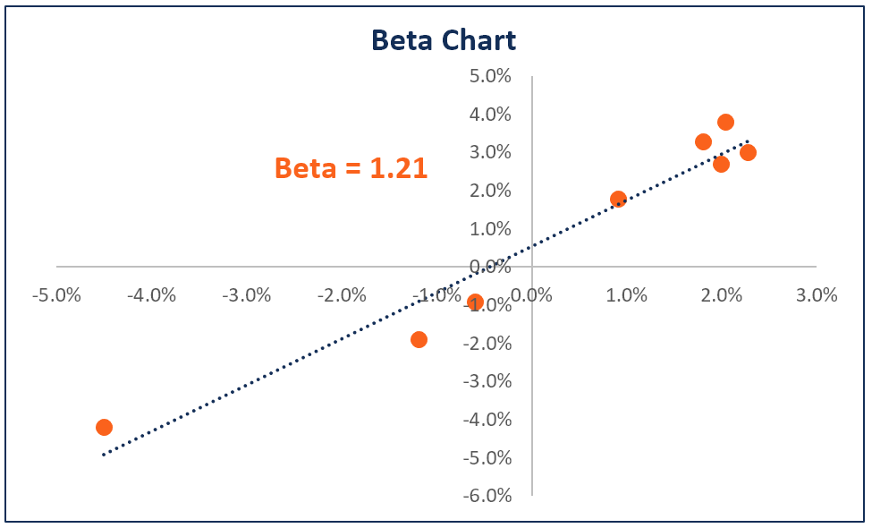

Examples of Beta
High β – A company with a β that’s greater than 1 is more volatile than the market. For example, a high-risk technology company with a β of 1.75 would have returned 175% of what the market returned in a given period (typically measured weekly).
Low β – A company with a β that’s lower than 1 is less volatile than the whole market. As an example, consider an electric utility company with a β of 0.45, which would have returned only 45% of what the market returned in a given period.
Negative β – A company with a negative β is negatively correlated to the returns of the market. For example, a gold company with a β of -0.2, which would have returned -2% when the market was up 10%.

Calculation
Below is an Excel β calculator that you can download and use to calculate β on your own. β can easily be calculated in Excel using the Slope function.
Follow these steps to calculate β in Excel:
- Obtain the weekly prices of the stock
- Obtain the weekly prices of the market index (i.e., S&P 500 Index)
- Calculate the weekly returns of the stock
- Calculate the weekly returns of the market index
- Use the Slope function and select the weekly returns of the market and the stock, each as their own series
- Congrats! The output from the Slope function is the β
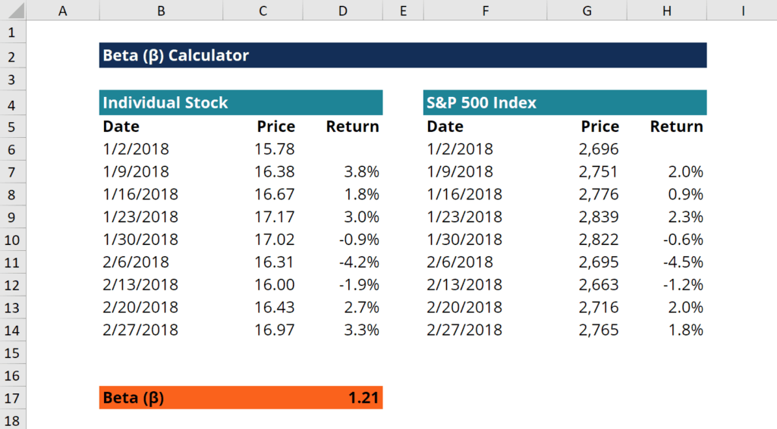

What are Valuation Multiples?
Valuation multiples are financial measurement tools that evaluate one financial metric as a ratio of another, in order to make different companies more comparable. Multiples are the proportion of one financial metric (i.e. Share Price) to another financial metric (i.e. Earnings per Share). It is an easy way to compute a company’s value and compare it with other businesses. Let’s examine the various types of multiples used in business valuation.
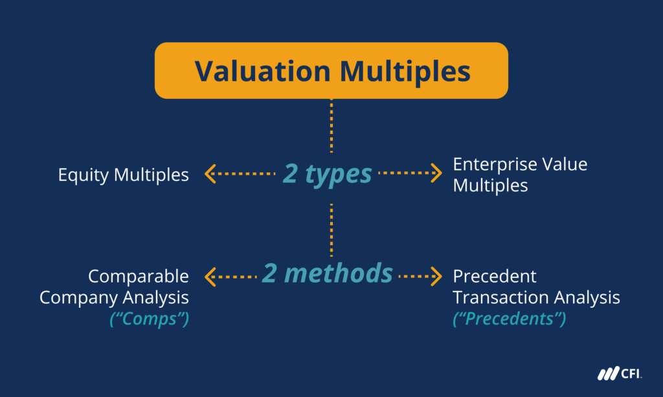

Types of Valuation Multiples
There are two main types of valuation multiples:
- Equity Multiples
- Enterprise Value Multiples
There are two main methods of performing analysis using multiples:
- Comparable Company Analysis (“Comps”)
- Precedent Transaction Analysis (“Precedents”)

Advantages and Disadvantages of Valuation Multiples
Using multiples in valuation analysis helps analysts make sound estimates when valuing companies. This is especially true when multiples are used appropriately because they provide valuable information about a company’s financial status. Furthermore, multiples are relevant because they involve key statistics related to investment decisions. Finally, the simplicity of multiples makes them easy to use for most analysts.
However, this simplicity can also be considered a disadvantage because of the fact that it simplifies complex information into just a single value. This simplification can lead to misinterpretation and makes it challenging to break down the effects of various factors.
Next, multiples portrait a snapshot of a company’s status rather than its potential. As such, they do show how a company grows or progresses. Therefore, multiples reflect short-term rather than long-term values.
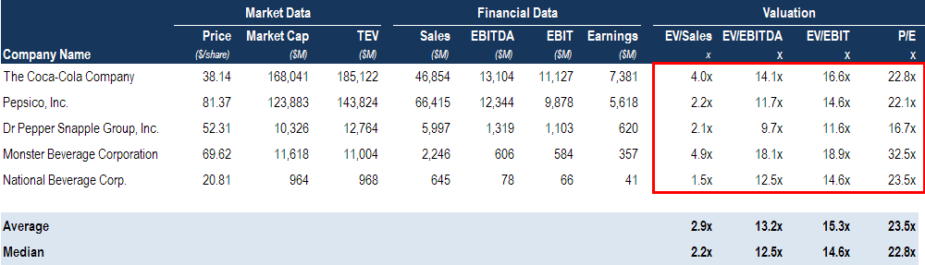
The image above is an example of Comparable Company Valuation Multiples from CFI’s Business Valuation Course.

1. Equity Multiples
Investment decisions make use of equity multiples especially when investors look to acquire minor positions in companies. The list below shows some common equity multiples used in valuation analyses.
- P/E Ratio – the most commonly used equity multiple; input data is easily accessible; computed as the proportion of Share Price to Earnings Per Share (EPS)
- Price/Book Ratio – useful if assets primarily drive earnings; computed as the proportion of Share Price to Book Value Per Share
- Dividend Yield – used for comparisons between cash returns and investment types; computed as the proportion of Dividend Per Share to Share Price
- Price/Sales – used for firms that make losses; used for quick estimates; computed as the proportion of Share Price to Sales (Revenue) Per Share
However, a financial analyst must take into account that companies have varying levels of debt that ultimately influence equity multiples.

2. Enterprise Value (EV) Multiples
When an assessment is needed on a merger and acquisition, enterprise value multiples are the more appropriate multiples to use, as they eliminate the effect of debt financing. The list below shows some common enterprise value multiples used in valuation analyses.
- EV/Revenue – slightly affected by differences in accounting; computed as the proportion of Enterprise Value to Sales or Revenue.
- EV/EBITDAR – most used in industries in the hotel and transport sectors; computed as the proportion of Enterprise Value to Earnings before Interest, Tax, Depreciation & Amortization, and Rental Costs
- EV/EBITDA – EBITDA can be used as a substitute of free cash flows; is the most used enterprise value multiple; computed as Enterprise Value / Earnings before Interest, Tax, Depreciation & Amortization
- EV/Invested Capital – used for capital-intensive industries; computed as the proportion of Enterprise Value to Invested Capital
There are many more equity and enterprise value multiples used in company valuation, this article only presented the most common ones. A thorough understanding of each multiple and related concepts can help analysts better apply multiples in making financial analyses.
Compare equity value and enterprise value.

Methods of Using Multiples
All of the above, are utilized within the two common approaches to valuation multiples:
- Comparable Company Analysis – This method analyzes public companies that are similar to the company being valued. An analyst will gather share prices, market capitalization, capital structure, revenue, EBITDA, and earnings for each company. Learn more about performing comparable company analysis.
- Precedent M&A Transactions – This method analyzes past mergers and acquisitions (M&A) for companies in the same industry, which can be used as a reference point for the company that is being valued. Learn all about performing precedent transaction analysis.
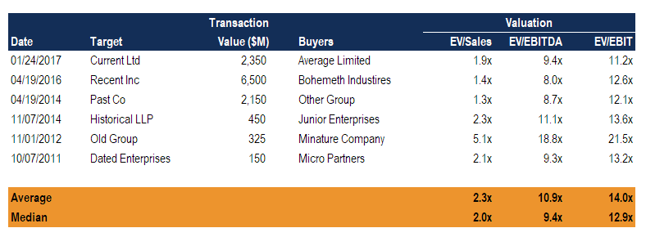

DCF Terminal Value Formula
What terminal value is, how to calculate it, and how it's used in a DCF analysis
Over 1.8 million professionals use CFI to learn accounting, financial analysis, modeling and more. Start with a free account to explore 20+ always-free courses and hundreds of finance templates and cheat sheets.
Start Free
Written by CFI Team

What is the DCF Terminal Value Formula?
Terminal value is the estimated value of a business beyond the explicit forecast period. It is a critical part of the financial model, as it typically makes up a large percentage of the total value of a business. There are two approaches to the DCF terminal value formula: (1) perpetual growth, and (2) exit multiple.
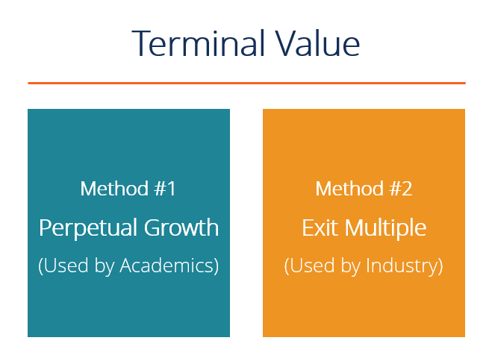
Image: CFI’s Business Valuation Course.

Why is a Terminal Value Used?
When building a Discounted Cash Flow / DCF model, there are two major components: (1) the forecast period and (2) the terminal value.
The forecast period is typically 3-5 years for a normal business (but can be much longer in some types of businesses, such as oil and gas or mining) because this is a reasonable amount of time to make detailed assumptions. Anything beyond that becomes a real guessing game, which is where the terminal value comes in.

What is the Perpetual Growth DCF Terminal Value Formula?
The perpetual growth method of calculating a terminal value formula is the preferred method among academics as it has a mathematical theory behind it. This method assumes the business will continue to generate Free Cash Flow (FCF) at a normalized state forever (perpetuity).
The formula for calculating the perpetual growth terminal value is:
TV = (FCFn x (1 + g)) / (WACC – g)
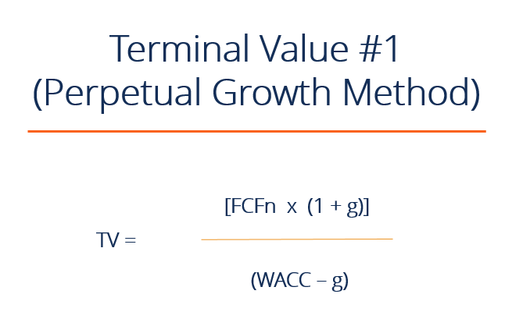
Where:
- TV = terminal value
- FCF = free cash flow
- n = year 1 of terminal period or final year
- g = perpetual growth rate of FCF
- WACC = weighted average cost of capital

What is the Exit Multiple DCF Terminal Value Formula?
The exit multiple approach assumes the business is sold for a multiple of some metric (e.g., EBITDA) based on currently observed comparable trading multiples for similar businesses.
The formula for calculating the exit multiple terminal value is:
TV = Financial Metric (e.g., EBITDA) x Trading Multiple (e.g., 10x)
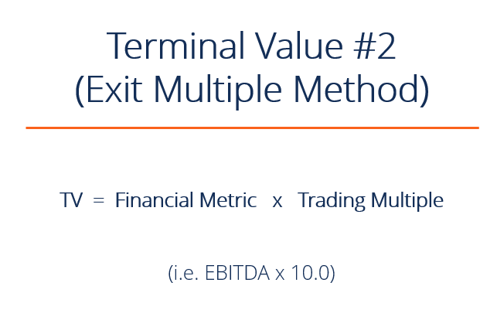

Which Terminal Value Method is More Common?
The exit multiple approach is more common among industry professionals, as they prefer to compare the value of a business to something they can observe in the market. You will hear more talk about the perpetual growth model among academics since it has more theory behind it. Some industry practitioners will take a hybrid approach and use an average of both.

Example from a Financial Model
Below is an example of a DCF Model with a terminal value formula that uses the Exit Multiple approach. The model assumes an 8.0x EV/EBITDA sale of the business that closes on 12/31/2022.
As you will notice, the terminal value represents a very large proportion of the total Free Cash Flow to the Firm (FCFF). In fact, it represents approximately three times as much cash flow as the forecast period. For this reason, DCF models are very sensitive to assumptions that are made about terminal value.
A common way to help represent this is through sensitivity analysis.
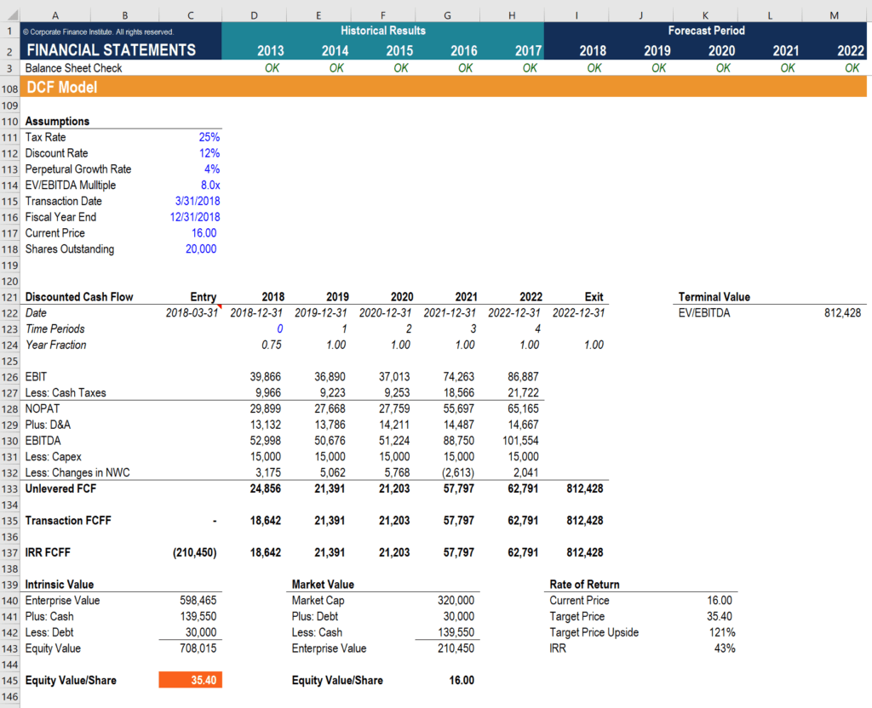
Image: CFI’s Financial Modeling Course.

Download the Free Template
Enter your name and email in the form below and download the free template now!

DCF Model Template
Download the free Excel template now to advance your finance knowledge!
Top of Form
- First Name*
- Email*
Bottom of Form
Top of Form
Bottom of Form
* By submitting your email address, you consent to receive email messages (including discounts and newsletters) regarding Corporate Finance Institute and its products and services and other matters (including the products and services of Corporate Finance Institute's affiliates and other organizations). You may withdraw your consent at any time.
This request for consent is made by Corporate Finance Institute, 801-750 W Pender Street, Vancouver, British Columbia, Canada V6C 2T8. www.corporatefinanceinstitute.com. learning@corporatefinanceinstitute.com. Please click here to view CFI`s privacy policy.

Video Explanation of Terminal Value
Below is a short video tutorial that explains how to calculate TV step by step in Excel. This example is taken from CFI’s financial modeling courses.

More Valuation Resources
To learn more about valuation and financial modeling, check out these additional CFI resources:
- Overview of Valuation Methods
- DCF Modeling Guide
- Advanced Excel Formulas
- DCF Analysis – Infographic
- See all financial modeling resources

Analyst Certification FMVA® Program
Below is a break down of subject weightings in the FMVA® financial analyst program. As you can see there is a heavy focus on financial modeling, finance, Excel, business valuation, budgeting/forecasting, PowerPoint presentations, accounting and business strategy.

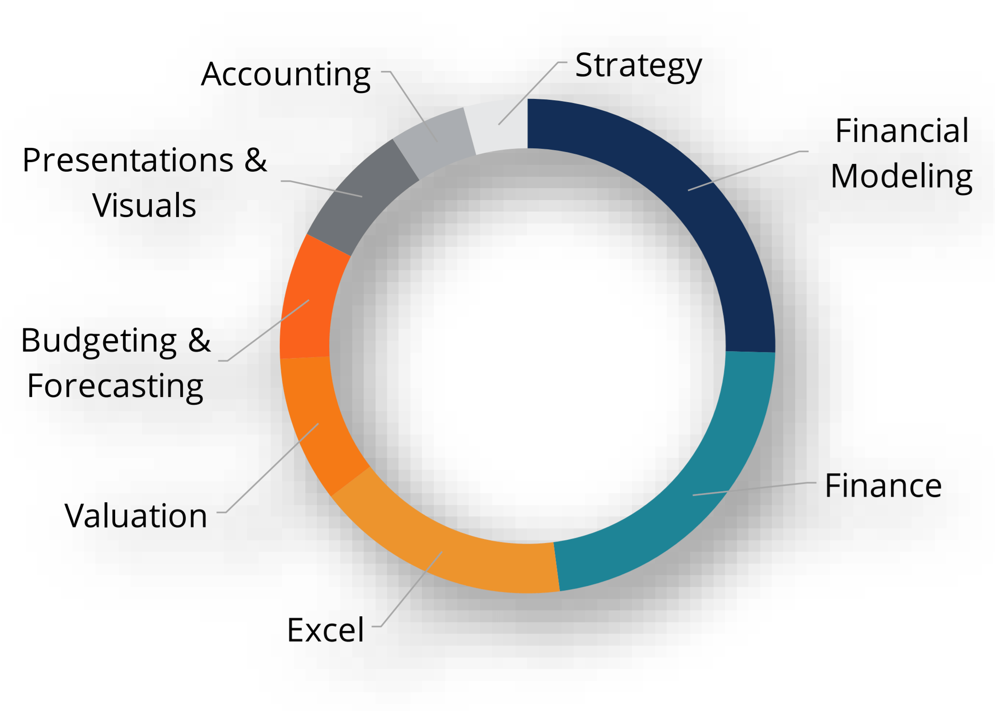

A well rounded financial analyst possesses all of the above skills!

