28 January 2025 13:36 582 words #708619
The world’s most valuable brands revealed (2025 Edition)

Apple has been crowned the world’s most valuable brand at US$355.1 billion, with Amazon (US$350.3 billion) and Google (US$263.4 billion) close behind.
These rankings, by Brand Finance, underscore how strategic storytelling and consistent brand experiences can build vast intangible value.
At Brandkit, we view these valuations as a testament to the power of authenticity. Amid abundant information, brands that foster real connections stand out - both in customers’ minds and on balance sheets. When brand and reputation align, trust thrives, loyalty grows, and value follows.
According to Brand Finance’s latest data, eight of the ten most valuable brands are tech giants:
- Apple: USD 574.5b, up 11%
- Microsoft: USD 461.1b, up 35%
- Google: USD 413.0b, up 24%
- Amazon: USD 356.4b, up 15%
- Walmart: USD 137.2b, up 42%
- Samsung Group USD 110.5b, up 11.2%
- TikTok/Douyin USD 105.8b, up 7.9%
- Facebook USD $91,5b, up 21%
- NVIDIA USD $87,871M, up 98%
- State Grid Corporation of China USD $85.6b, up 20%
Countries represented in the report
Top countries:
- United States: 193 brands
- China: 69 brands
- Germany: 27 brands
- Japan: 36 brands
- France: 35 brands
- United Kingdom: 20 brands
- India: 15 brands
- Canada: 15 brands
- Italy: 14 brands
- Other countries : 76 brands
Leading sectors
Top sectors:
- Banking: 78 brands
- Retail: 45 brands
- Insurance: 30 brands
- Telecoms: 27 brands
- Media: 24 brands
- Oil & Gas: 23 brands
- Diversified: 22 brands
- Engineering: 22 brands
- Automobiles: 21 brands
- Other sectors: 208 brands
Biggest brand growth since 2020
- TikTok/Douyin: USD105.8b, up from USD59.0b
- DraftKings: USD5.1b, up from USD18m
- FanDuel: USD7.0b, up from USD56m
- NVIDIA: USD87.9b, up from USD4.7b
- AMD: USD11.0b, up from USD1.4b
- Pinduoduo: USD13.0b, up from USD2.5b
- BYD: USD14.0b, up from USD3.1b
- Apple: USD574.5b, up from USD140.5b
- TSMC: USD34.2b, up from USD8.6b
- Microsoft: USD461.1b, up from USD117.1b
- Lilly: USD8.0b, up from USD2.1b
American gambling brands DraftKings and FanDuel are cashing in as online gambling becomes legal in more American states. Semiconductor brands NVIDIA, AMD, and TSMC advance new technologies, while tech giants Apple and Microsoft lead from the front.
“Technology companies do not have a monopoly on sustained brand growth,” says David Haigh, Founder & CEO, Brand Finance. “Chinese brands like Pinduoduo, and BYD create value and challenge established leaders.”
Other highlights
- e& (e&, formerly branded as Etisalat, is a UAE state-owned telecommunications company. It is the 16th largest mobile network operator in the world by number of subscribers) is the world’s fastest-growing brand value
- WeChat (WeChat or Weixin in Chinese is a Chinese instant messaging, social media, and mobile payment app developed by Tencent) is the strongest brand, scoring 95.2/100
While global economic growth is forecast to hover at 2.8% in 2025, the 500 most valuable brands are up 10% year-on-year. At Brandkit, we view this as proof that authentic, purposeful brand experiences remain vital for success - even when external pressures persist.
Brand Finance
This most valuable brands data is an excerpt from Brand Finance’s Global 500 Report - learn more here: Brand Finance
Source: Brand Finance
Register/Login to access Article B Authentic Blog Brand Kit Brand Management Brand Management Software Brand Strategy Brand System Brand Visuals Digital Branding Do Authentic
Join 194,164 + users already on Brandkit
Your story matters. Help your collaborators find your content, tell your story with confidence, and build a stronger brand. All for a reasonable and fair price. See pricing here.

Subscribe to Updates Tour Book a Demo
Statistics above last updated 1 March 2024

Independent Reviews via Gartner Group

"Easy to use."

"Great value product."

"Great to work with."
Brandkit is headquartered in New Zealand. First to see each new day. First to see the future. Trusted by brands large and small. 100% self-funded and independent for over 25 years.
Why Brandkit? B Authentic Our story Our Manifesto Our Brand FAQ Terms of Service SLA - Service Level Agreements Terms of use Privacy Cookies Security Sustainability Accessibility API Fair Use Policy Jobs at Brandkit Help Centre Contact us Refer a friend Platform Everything together Search Page Brand Portal Digital Asset Management (DAM) Content Management (CMS) Posts and the Writing tool Links (New) Collaboration File Transfers Embeds Licencing Content Attribution Brand Guidelines Attachments Passwordless Multi-lingual Multiple Portals Content Syndication Parter/Stakeholder Network Personalisation Batch Editing/Tagging Image Auto-tagging People and Access Public Uploads/Contributions Reporting and Analytics Custom Design New in 2 All Features Pricing Brand-Safe™ Use Cases Destination Marketing Tourism Place Branding Economic Development Hospitality Education Product Marketing Service Marketing Creative and PR Agencies Case Studies Brand Management Image & Video Library Digital Asset Management Content Management Content Marketing Digital Branding Branding System Resources Our Blog Case Study: The Coromandel Case Study: Enterprise Dunedin Case Study: VisitScotland Case Study: Mitsubishi Motors eGuide: Curating and Managing Brand Content Whitepaper: Selecting a DAM Solution What is a Brand Portal? Branding System DAM Learning Centre Image Management Media Asset Management Why DAM? Why NOT DAM? DAM vs Dropbox Brandkit vs Bynder Brandkit vs CrowdRiff Brandkit vs Simpleview Brandfolder vs Canto vs Brandkit DAM for Destination Marketing What is Branding Automation The Good Brand Checklist Don't do junk content

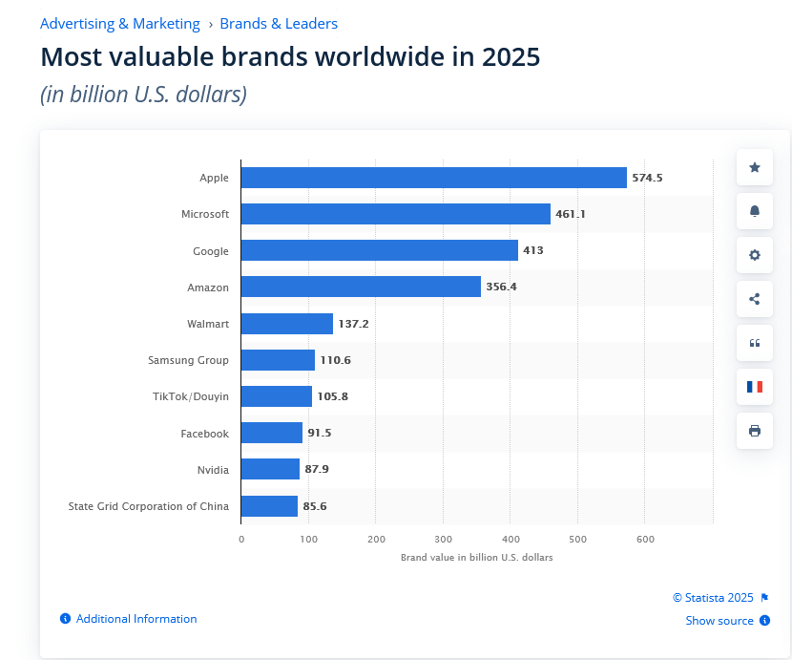

Tech titans top the world's most valuable brands league in 2025
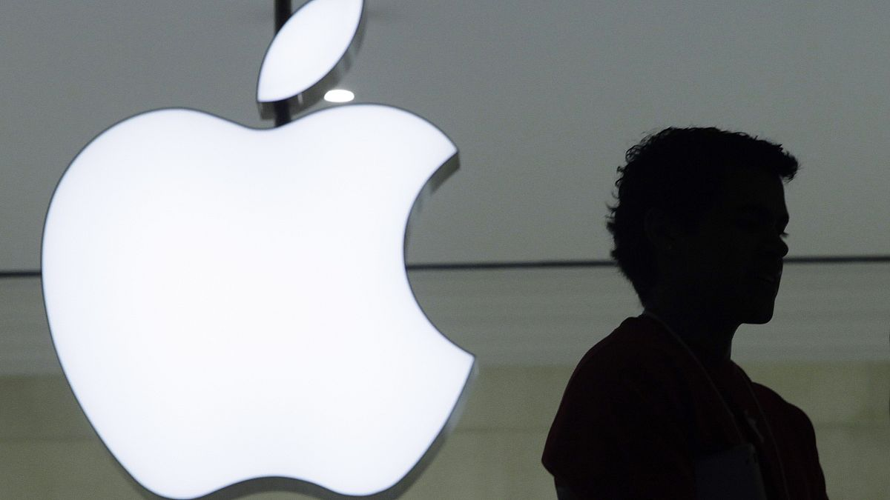
Copyright AP Photo/Mark Lennihan
By Indrabati Lahiri
Published on 22/01/2025 - 7:20 GMT+1
Share this article
Comments
Tech companies continued to be some of the world’s most valuable brands this year, boosted by ongoing strong brand loyalty, as well as new innovations in artificial intelligence.
The world’s top 500 most valuable brands grew their brand value by 10% in the last year, coming up to $9.5tn (€9.14tn) in 2025. This was in contrast to global economic growth, which came up to 3%. Tech brands led this rise, with three of the top five brands being tech companies.
Brand Finance released its Global 500 report on Tuesday, which revealed the 500 most valuable brands globally for 2025.
Apple took the crown once again in first place, with a brand valuation of $574.5bn (€552.94bn) in 2025, according to Brand Finance, which was an increase of 11%. The brand has captured the top spot every year since 2021, except for 2023, when it marginally missed out by 1%, when Amazon took the top spot.
This year, Microsoft took second place, with its brand valuation soaring 35% to $461.1bn (€443.8bn). Google came in at third position, with a brand valuation of $413.0bn (€397.62bn), which was a rise of 24% compared to the last year.
Amazon took fourth place, with a brand valuation of $356.4bn (€343.2bn), which was a jump of 15%, whereas Walmart came in at fifth position, with a brand valuation of $137.2bn (€132.12bn), a rise of 42%.
Samsung, TikTok/Douyin, Facebook, Nvidia and State Grid Corporation of China were also amongst the top 10 brands this year. Nvidia was part of the top 10 list for the first time, following its brand value surging 98% in the last year.
TikTok/Douyin, DraftKings, Fanduel, Nvidia and AMD were some of the companies which had seen the most brand value growth since 2020, along with Pinduoduo, BYD, Apple, TSMC, Microsoft and Lilly.
David Haigh, chairman and chief executive officer (CEO) of Brand Finance, said in a press release: “Our analysis of what brands have grown the most since 2020 reveals that technology companies do not have a monopoly on sustained brand growth.
This longer-term view also reinforces another important global trend: how Chinese brands like TikTok, Pinduoduo, and BYD are leading the charge by creating value, and challenging established brand leaders. As China continues to refine its brand-building strategies and focus on quality, we expect to see more Chinese companies enter the global marketplace in 2025.”
Related
- European luxury stocks rally as Richemont posts record quarterly sales
New innovations and robust brand loyalty boosting tech company growth
Apple’s brand value has increased heavily lately due to its ongoing strong brand loyalty. The company launched the iPhone 16 in September 2024, along with the iPad Pro and iPad Air back in May. The iPad mini was also launched in October 2024.
However, it has also diversified more recently, while also furthering its artificial intelligence progress.
Haigh said in an earlier press release: “Apple has grown its brand value through strategic diversification and premiumisation, moving away from heavy reliance on iPhone sales towards ventures into wearables and services such as Apple TV subscriptions.
“According to our research, more than 50% of respondents recognised Apple as expensive, but worth the price, reinforcing the brand’s ability to demand a price premium”.
Similarly, Microsoft has also been investing heavily in artificial intelligence in the last year, especially through collaborations with OpenAI. This is a long-term partnership worth several billions of dollars, which focuses on supercomputing and new AI-powered experiences.
Amazon’s cloud computing operations and e-commerce have drawn a lot of investor optimism in the last year, contributing to the brand’s growth. This has been helped by the company’s growth in revenue in the past year. Furthermore, the company has focused more on increasing its selection of goods and enhancing its delivery speed.
Similarly, Walmart has focused more on growing its marketing and advertising revenue in the last year, while also improving its digital services and attracting wealthier shoppers.
Related
- Billionaire wealth surges as Oxfam predicts five trillionaires in decade
US leads in terms in brand value
The United States accounted for 52.9% of the top 500 companies’ total brand value, according to Brand Finance, with 194 brands. China came in second at 15% with 69 brands. In third position was Germany, at 5.8%, with 27 brands.
Although Japan, at fourth place, accounted for 5.1% of total brand value, it had a higher number of brands than Germany, at 36. Similarly, France, at fifth position had 35 brands, but only accounted for 4.4% of total brand value.
Coming to the top industry in terms of brand value, banking took the crown at 12.7% of total brand value, with 78 brands. Retail followed closely at 11.4%, with 45 brands, whereas media was in third position at 10.3% with 24 brands. The electronics industry accounted for 8.2% of total brand value, with the internet and software industry coming in at 6.5%.

https://www.go-globe.com/top-global-brands-2024-2025/
https://brandfinance.com/press-releases/apple-is-the-2025-most-valuable-brand-in-the-world-nvidia-breaks-into-top-ten

https://interbrand.com/best-global-brands/

https://www.merca20.com/the-500-most-valuable-brands-according-to-the-brand-finance-2025-ranking/

