Adjusting for Inflation
by Diego Mendez-Carbajo
"The burdens of high inflation fall heaviest on those who are least able to bear them."
—Federal Reserve Chair Jerome Powell¹

Introduction
Inflation raises the general price level for goods and services in an economy and reduces the purchasing power of a dollar over time. This means that, year after year, with a fixed amount of money you're able to buy fewer items at the grocery store or access fewer services like haircuts or car repairs.
Adjusting for inflation means measuring dollar amounts in constant prices. Economists use jargon to name dollar amounts that have been adjusted for the impact of inflation: That word is "real." For example, wages or interest rates can be adjusted for inflation, giving us a "real wage" or "real interest rate." You can compare real values today with real values from the past because the general price level is held constant.
Monetary values are called nominal values when measured in current prices. Comparing nominal values from the past with nominal values today makes very little sense because the purchasing power of the dollar changes as prices change.
The general price level is measured through an index—a number used to represent the change in value of prices between a base date and a different date. A price index typically has a value of 100 on the base date.² The percent growth rate in the price index is what economists call inflation.³ For example, if the index rises from 100 in the base year to 105 today, we can say that inflation is 5 percent. A price index can be used to measure the change in prices over time and to transform nominal dollar values into real dollar values. It can also be used to adjust nominal values over time so that their real value stays constant. That type of adjustment is called indexing.
Stable prices are very important for making good economic decisions about spending and saving money. That is why promoting price stability is part of the Federal Reserve's mandate from Congress. Understanding how monetary values can be adjusted for inflation helps you make better economic decisions. Read on to learn how to calculate real monetary values.

How to Calculate a Real Wage Value
Most economic statistics are reported in current, or non-inflation-adjusted, dollar values—that is, nominal values. In fact, unless a monetary value includes "real" or "measured at constant prices" in its name, you should consider it a nominal value. For example, Congress sets the federal minimum wage as a nominal amount of dollars per hour of work.
To calculate the real value of a nominal wage, divide it by a price index that represents the prices earners pay to buy goods and services. Multiply this amount by 100 if the price index has a value of 100 on its base date. The consumer price index (CPI), reported by the U.S. Bureau of Labor Statistics (BLS), is commonly used to calculate real wages and earnings.⁴ The formula used in that calculation is
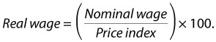
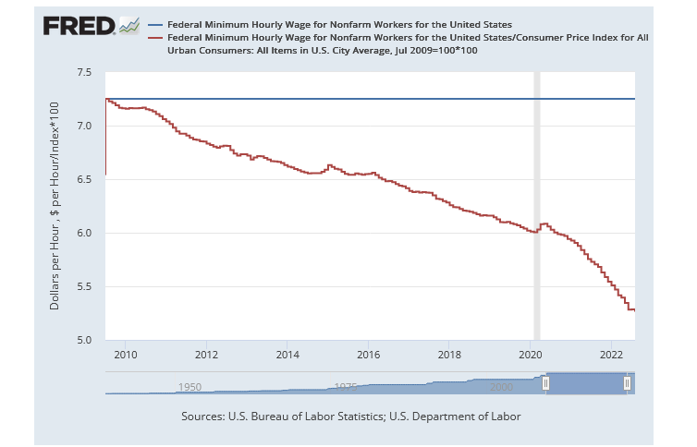
Nominal and CPI-Adjusted Federal Minimum Wage
SOURCE: U.S. Bureau of Labor Statistics and U.S. Department of Labor via FRED®, Federal Reserve Bank of St. Louis; https://fred.stlouisfed.org/graph/?g=TEfq, accessed September 13, 2022.

Figure 1 shows the nominal minimum wage employers are mandated by Congress to pay employees (blue line) and the real minimum wage (red line), using the CPI to adjust for inflation. The base date for the CPI used to build this graph is set to July 1, 2009, when Congress raised the nominal minimum wage to $7.25 per hour.⁵ Note that in that month the real and nominal values are the same because the price index has a value of 100. Between July 2009 and the time of this writing, the real value of the minimum wage decreased by 27% because the nominal minimum wage didn't change and the general price level increased; that is, we've experienced inflation.

How to Calculate the Current Value of a Dollar Amount from a Past Value
When you compare past dollar values to current dollar values, it is also important to adjust values for inflation. The cumulative impact of inflation on prices makes dollar amounts from decades ago seem very small. For example, during its first year in movie theaters (1977-78), ticket sales for the original Star Wars movie totaled slightly more than $260 million.⁶
You can use the CPI to calculate the current value of a past dollar amount. Multiply the past, or original, dollar amount by the current CPI and divide it by the past CPI (when the original dollar amount was recorded). The formula is
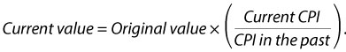
In the case of Star Wars: Episode IV—A New Hope (as it came to be known some years later), that past value of $260 million amounts to almost $1,279 million in August 2022 dollars.⁷ That is more than ticket sales from the two most-popular movies in 2022 combined.⁸

How to Index a Monetary Value to the CPI
Some nominal dollar values are regularly adjusted for inflation in the procedure known as indexing. When a dollar amount is indexed, its nominal value goes up every year to keep pace with inflation. For example, the U.S. Social Security Administration adjusts the dollar value of benefits it pays to retired or disabled workers and their surviving families according to changes in the CPI for people who live in cities and earn a wage.⁹ In January 2022, those benefits rose by 5.9%. The formula economists use to index a dollar value to inflation is the same formula used to calculate the current value of a dollar amount from a past value. (See boxed insert "Headline Price Indexes.")

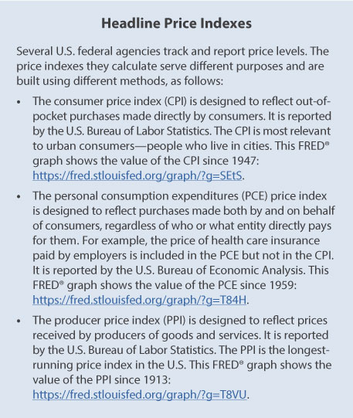
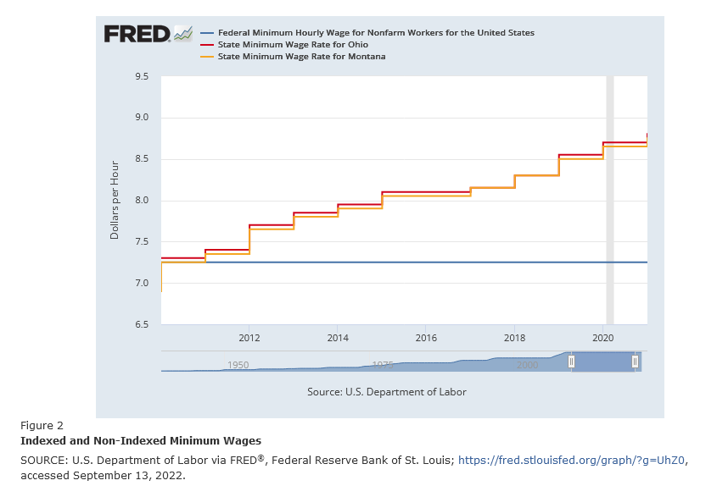
At the time of this writing, nine states use indexing to calculate the minimum wage employers are required to pay employees in their states.¹⁰ Figure 2 shows three nominal minimum wages in the U.S.—federal (blue line), Ohio (red line), and Montana (orange line). The federal minimum wage is constant and the minimum wages in Ohio and in Montana increase year after year. In 2006, those state legislatures passed constitutional amendments to adjust nominal minimum wages, adopting the same formula used by the Social Security Administration described above.

How to Calculate a Real Interest Rate
An interest rate is the price people pay for borrowing money, and it's the price people receive for lending money. That is, it's the percentage of the amount of a loan that is charged for a loan, and it's the percentage paid on the balance in a savings account. Interest payments are made or received for months or years, and during that time the general price level is very likely to rise—meaning there will be some inflation.
For example, the interest rate on a 30-year mortgage loan determines the nominal payment a borrower has to make every month to pay the loan back. What would inflation be during that time? Nobody knows for sure, but inflation will certainly reduce the real value of those payments. Economists use a statistic known as the breakeven inflation rate to measure how inflation is expected to change in the future.¹¹
To calculate the real value of an interest rate, subtract the value of expected inflation from the nominal interest rate. The formula used in that calculation is
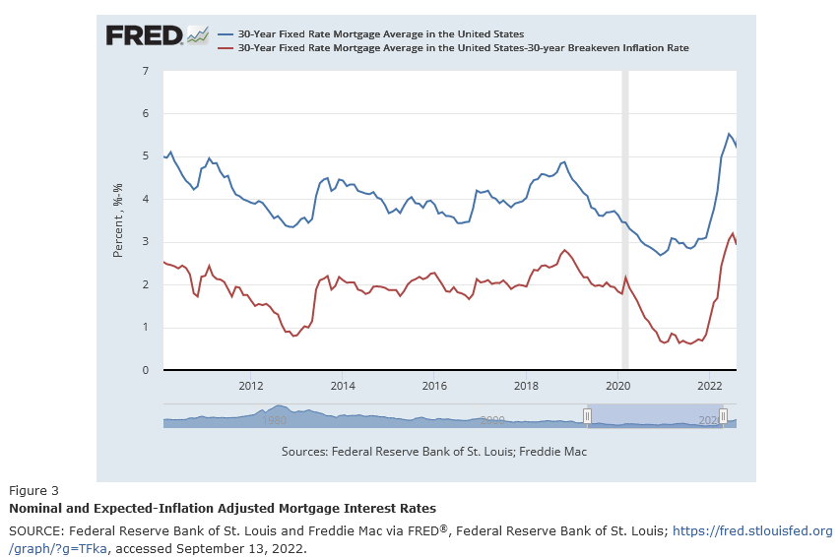
Figure 3 shows the average nominal interest rate on a mortgage loan paid back over 30 years (blue line) and the real interest rate (red line). Note that the distance between the blue and red lines is the expected inflation rate over those 30 years. Its average value is 2.1%, although it fell to 1.29% at the start of the COVID-19-induced recession in 2020.¹²

Conclusion
Inflation raises the nominal price of goods and services; using economics and a little math helps you figure out the real value of a dollar. Comparing the nominal and real values of a wage accurately shows its purchasing power. Calculating the current value of a dollar amount from a past value helps accurately tell the story behind the numbers (such as just how popular the original Star Wars movie really was in 1977-78).
Indexing Social Security benefits or minimum wages to a headline price index helps maintain their constant purchasing power. Calculating the real interest rate charged on loans shows the inflation-adjusted costs of borrowing money that is paid back in the future. Adjusting nominal dollar values and interest rates for inflation is important to make good economic decisions.

Notes
¹ Powell, Jerome. "Monetary Policy and Price Stability." Presented at a symposium sponsored by the Federal Reserve Bank of Kansas City, "Reassessing Constraints on the Economy and Policy," Jackson Hole, Wyoming, August 26, 2022; https://www.federalreserve.gov/newsevents/speech/powell20220826a.htm.
² For more about price indexes, see the following article: Garriga, Carlos and Werner, Devin. "Inflation, Part 2: How Do We Construct and Choose an Index?" Federal Reserve Bank of St. Louis Economic Synopses, 2022, No. 16; https://doi.org/10.20955/es.2022.16.
³ For more about calculating inflation, see the following article: Garriga, Carlos and Werner, Devin. "Inflation, Part 1: What Is it, Exactly?" Federal Reserve Bank of St. Louis Economic Synopses, 2022, No. 15; https://doi.org/10.20955/es.2022.15.
⁴ The Figure 1 FRED® graph shows the nominal and real typical (median) usual weekly earnings of wage and salary workers, 16 years of age and over, reported by the U.S. Bureau of Labor Statistics since 1979; https://fred.stlouisfed.org/graph/?g=TB8B. Both data series have the same value between the second and third quarter of 1983 because the BLS uses the CPI to adjust earnings for inflation, and the base date of the CPI includes the years 1982-84.
⁵ For more on interpreting data units, see the following article: Mendez-Carbajo, Diego. "Data Units in FRED®." Federal Reserve Bank of St. Louis Page One Economics, Data Primer, November 2021; https://research.stlouisfed.org/publications/page1-econ/2021/11/15/data-units-in-fred.
⁶ Hollywood (AP). "Grease Leads Summer Films as Top Box-Office Draw." Postmedia Network Inc., Star-Phoenix, September 7, 1978, p. 10; https://news.google.com/newspapers?id=jZVjAAAAIBAJ&sjid=YnoNAAAAIBAJ&pg=1179,1672206.
⁷ The amount of $1,279 is (approximately) equal to $260.4 x (295.62/60.2)—decimals matter!
⁸ Box Office Mojo. "Domestic Box Office for 2022." IMDbPro, September 13, 2022; https://www.boxofficemojo.com/year/2022/?grossesOption=totalGrosses.
⁹ For more about adjusting Social Security benefits using the consumer price index, see the following publication: Social Security Administration. "Social Security Cost-of-Living Adjustments and the Consumer Price Index." Social Security Bulletin, 2007, 67(3), p.73; https://www.ssa.gov/policy/docs/ssb/v67n3/v67n3p73.pdf.
¹⁰ For more about state minimum wages, see the following webpage: National Conference of State Legislatures. "State Minimum Wages." August 30, 2022; https://www.ncsl.org/research/labor-and-employment/state-minimum-wage-chart.aspx.
¹¹ For more about the breakeven inflation rate, see the following post: Andolfatto, David and Steinberg, Joel. "Measuring Expected Inflation with Breakevens." Federal Reserve Bank of St. Louis FRED® Blog, December 2, 2021; https://fredblog.stlouisfed.org/2021/12/measuring-expected-inflation-with-breakevens/.
¹² For breakeven inflation rates over 5, 10, and 20 years, see the "Interest Rate Spreads" category of FRED® data: https://fred.stlouisfed.org/categories/33446.

© 2023, Federal Reserve Bank of St. Louis. The views expressed are those of the author(s) and do not necessarily reflect official positions of the Federal Reserve Bank of St. Louis or the Federal Reserve System.

Glossary
Breakeven inflation rate: A measure of expected inflation calculated by comparing the interest rates of two types of bonds issued by the U.S. government.
Consumer price index (CPI): A measure of the average change over time in the prices paid by urban consumers for a market basket of consumer goods and services.
Index: A number used to represent the change in value of a magnitude (frequently a price level) between a base date and a different date. An index typically has a value of 100 on the base date.
Inflation: A general, sustained upward movement of prices for goods and services in an economy.
Interest rate: The percentage of the amount of a loan that is charged for a loan. Also, the percentage paid on a savings account.
Price stability: A low and stable rate of inflation maintained over an extended period of time.

