08/11/2024

Sponsored by 

Tariffs in Post-Election Spotlight; Suppliers Furnishing Wayfair Sales

By Paul Page

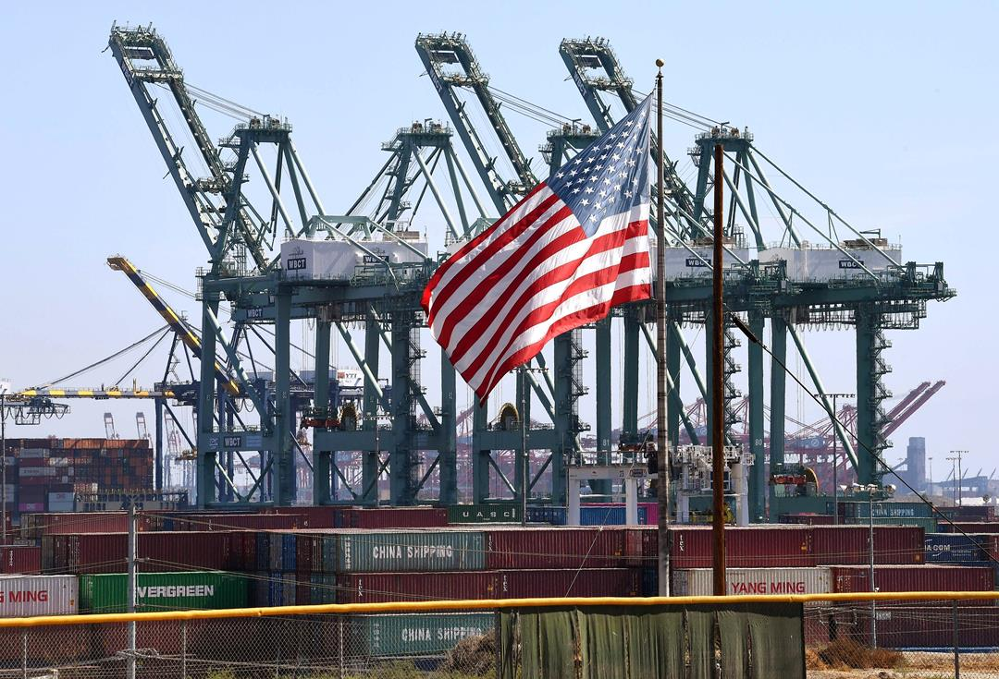
The Port of Long Beach, Calif., is one of the largest gateways in the U.S. for imports from Asia. PHOTO: MARK RALSTON/AGENCE FRANCE-PRESSE

Companies that depend on global trade are bracing for a wave of new tariffs under a second Trump administration. An aggressive set of levies promised by President-elect Trump could reset the flow of goods around the world, effectively reshaping global supply chains as retailers, manufacturers and shipping companies weigh a changed economic landscape.
The WSJ Logistics Report’s Liz Young writes that the tariffs would likely have a significant impact on American importers and on exporters who may find their access to overseas markets complicated by a regime of tit-for-tat levies. The broad outlines may follow the patterns that Trump established in his first administration, which was marked by a trade war with China and hefty tariffs even on traditional trading partners.
But Trump has signaled he’d go further this time, with talk of tariffs on all imports and big levies of some 60% on imports from China. The impact in the coming months is likely to be a scramble by U.S. importers to pull forward orders from overseas before tariffs kick in, a rush that shipping industry officials say would eat up shipping capacity and drive up freight rates.
Longer-term, that may accelerate nearshoring strategies and likely raise the costs of goods. The effects may reach well beyond the U.S. market.
- Shares in apparel companies fell as investors digested the impact of potential tariff increases on companies that source and manufacture their goods abroad. (WSJ)
- Donald Trump’s opposition to the CHIPS Act leaves U.S. factory plans for Samsung and Taiwan Semiconductor Manufacturing uncertain. (Nikkei Asia)
