How Iran War Is Disrupting the Food Supply Chain
By Agnieszka de Sousa, Eleanor Thornber, and Pyotr Kozlov
March 19, 2026 at 1:20 PM GMT+2
The arid Persian Gulf is hardly the world’s breadbasket. Yet the conflict in the region is sending shockwaves through the global food industry — from growers to packaging firms and distributors — with major implications for food security and living standards.
The war has cut off important sources of energy and fertilizers that are key inputs in the production of grains, vegetables and meat. Farmers whose crop yields were already squeezed by bouts of extreme weather now face having to pay more for those crucial inputs and are likely to pass on the cost to consumers through higher prices.
Their other option is to cut back on fertilizer and other inputs, lowering yields and raising the risk of food shortages, especially in poorer countries that rely heavily on imports. The United Nations’ World Food Programme has warned that a prolonged conflict could lead to record levels of global hunger.
How is the war affecting fertilizer production?
The Gulf region has become a significant producer of nitrogen fertilizers in recent decades, and the Strait of Hormuz was handling about a third of the global trade before the war broke out. The conflict has severely disrupted exports from the region, sending prices soaring and farmers scrambling to secure enough of the products while they can.
The war is also disrupting production of nitrogen fertilizers in other parts of the world as the conflict has affected supplies of their key ingredient, natural gas. This has led fertilizer manufacturers in countries such as India and Bangladesh to reduce output. There are signs that soaring gas prices are also putting European production under strain.
Nitrogen fertilizers underpin roughly half of global food production by supplying plants with nutrients that support their growth. If the disruption persists, farmers are likely to cut back their fertilizer use, leading to lower crop yields. “This is not only a price shock. It could also become a production shock with a lag built in,” said Wesley Davis, an economist at Meridian Agribusiness Advisors.
Persian Gulf Economies Exported $50 Billion of Nitrogen Fertilizers Since 2020
Imports from Oman, Qatar, Saudi Arabia, UAE, Bahrain and Iran between 2020–2025
Note: Some economies lag in reporting. Figures for commodity code HS 3102, Nitrogenous mineral or chemical fertilizers.
Source: Bloomberg analysis of imports from Trade Data Monitor
How else is the Iran war disrupting the food industry?
There is no modern food production without energy. Diesel-powered tractors till the soil and fresh produce is grown in gas-heated glasshouses. Oil-based fuels power the ships, airplanes and trucks that transport staples over long distances in today’s globalized economy. Oil is also the raw material used to make plastic food wrappings.
The war is straining supplies of the fuels needed to operate the machinery that sows and harvests crops, sprays chemicals and waters plants. Australian grain growers are facing fuel delivery cutbacks ahead of the planting season. In Bangladesh, some rice farmers cannot secure diesel to power irrigation pumps, while fishermen in the Philippines may soon need to keep their boats ashore.
Disruption of the Strait of Hormuz and the Red Sea shipping routes has raised freight costs and lengthened transit times for grains, oilseeds and fertilizers. Even short journeys face an impact as higher fuel prices make land transportation costlier.
Then there’s packaging. The Middle East region supplies about one-third of globally traded naphtha, the ingredient in production of polymers used in plastic wrappings, according to Rabobank. Paper and cardboard production is also energy intense. “Packaging converters, consumer brands, and ultimately retailers and consumers could all feel the effects,” the bank said.
Higher oil prices tend to boost demand for biodiesel and renewable diesel, leaving less of the commodities used to produce those alternative fuels — such as soybeans, canola and corn — available for the food industry. That’s likely to inflate prices, particularly in Africa, Asia and other import-dependent regions, the UN’s Food and Agriculture Organization said.
What will it all mean for food prices in stores?
Before the war broke out, food inflation around the world was generally expected to ease this year. Food commodity costs are still well below their peak of March 2022 following Russia’s full-scale invasion of Ukraine, but the impact of the war is starting to feed through into official price gauges. In Turkey, consumers were paying about a third more for their vegetables than before the conflict started.
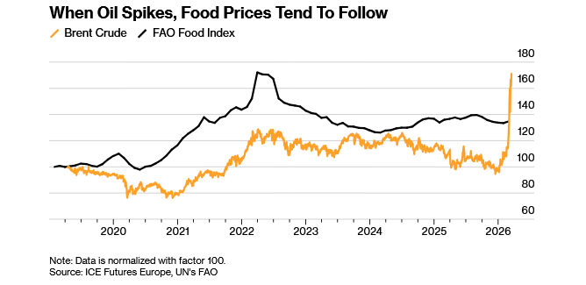
The full impact is likely to take some time to materialize. Food prices tend to respond to prolonged energy shocks, not short spikes, and the effect on grocery prices is typically indirect and delayed, according to David Ortega, a professor of food economics at Michigan State University.
(Sign up to the Business of Food newsletter for a weekly catchup on how the world feeds itself in a changing economy and climate.)
What are the likely economic repercussions?
Higher food prices will complicate efforts by central banks to get a post-pandemic wave of inflation back under control. The situation also presents a challenge for politicians, especially in emerging-market economies where food eats up a greater proportion of household incomes than it does in more industrialized nations.
Governments are already intervening in markets to secure enough fertilizers for local farmers. India has turned to China to allow the sale of some urea cargoes, which in turn is tightening its curbs on fertilizer exports. The Philippines government is in talks with major fertilizer producers, while the US Trump administration has moved to locate backup sources of fertilizers for American farmers and authorized Venezuela to sell them to US companies.
Who’s most at risk?
Import-dependent countries in Asia, Africa, and Latin America are particularly exposed to fertilizer shortages and rising input costs, the FAO said on March 15. While farmers in rich nations can count on support from their governments, concerns are mounting over some of the poorest economies.
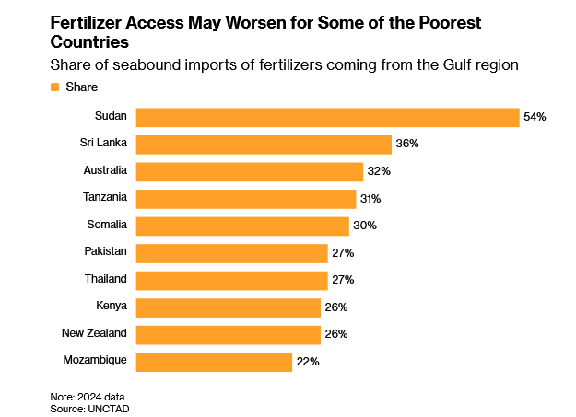
Many developing nations are struggling to service their debts and have only a limited capacity to absorb new price shocks, UN Trade and Development has warned. Higher fertilizer prices are likely to hit resource-poor farmers the hardest, risking smaller harvests and increased food price inflation down the line.
As many as 45 million more people could face acute hunger if the conflict in Iran doesn’t ease by the middle of the year, taking the total number to a record high, the WFP warned. Further increases in food insecurity could spell catastrophe for some of the world’s most vulnerable countries that are already at risk of famine, it said.
— With assistance from Erin Ailworth

US Senators Call for Fertilizer Price Transparency as Costs Soar
By Michael Hirtzer
March 19, 2026 at 11:46 PM GMT+2
A bipartisan group of US Senators introduced a bill that would require mandatory price reporting of fertilizer — a bid for more market information after the war in Iran prompted the biggest surge in crop nutrient costs in years.
“At a time when rising fertilizer costs and low commodity prices are continuing to erode farmers’ profitability, we should be increasing price transparency for farmers in the current market and increasing domestic fertilizer production and storage here at home,” Senator Amy Klobuchar, Democrat from Minnesota, said in a statement.
Farmers across the world are scrambling to secure enough fertilizer ahead of the spring planting season in the Northern Hemisphere. Politicians and trade groups are looking for ways to help growers, who have been struggling for years against relatively low crop prices and high costs for equipment, seeds and fertilizer.
The so-called Fertilizer Transparency Act would “offer market participants of all sizes with comparable levels of market information on fertilizer components.” The bill is also sponsored by Senators including Republicans John Thune of South Dakota and Roger Marshall of Kansas.
Because fertilizer is produced primarily outside the US, pricing can be seen as opaque, according to some critics of the sector.
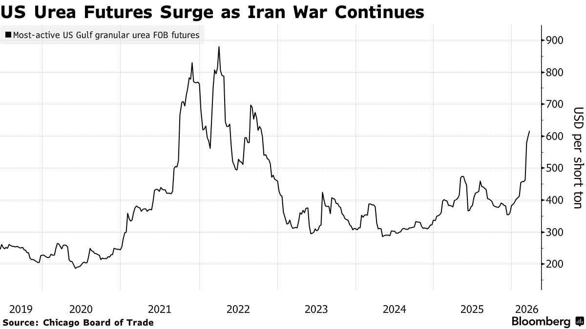

War In Iran Is Creating a Fertilizer Crisis Like Never Before
Surging prices for urea, ammonia and other nitrogen products.
By Tracy Alloway and Joe Weisenthal
March 11, 2026 at 10:00 AM GMT+2
We all know that the war with Iran has sent oil prices spiking. But it’s also pushing up the cost of all sorts of chemicals, including fertilizers like urea, ammonia and other nitrogen products that are essential for food production. This is all happening at the worst possible time — just before the spring planting season, when fertilizer is most needed. And while farmers have seen higher spot prices for things like urea before, notably back in 2022, there are already signs that this crisis might be worse. So how is fertilizer actually made? And what do higher fertilizer costs mean for farmers and for food prices? On this episode we speak with Alexis Maxwell, senior analyst on Bloomberg Intelligence's agriculture team.

