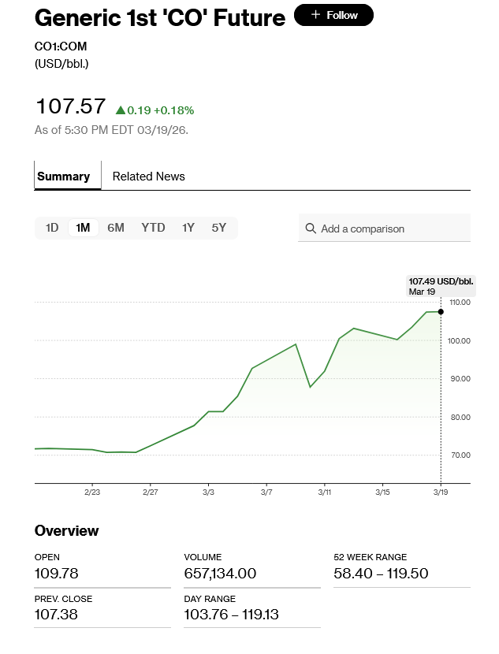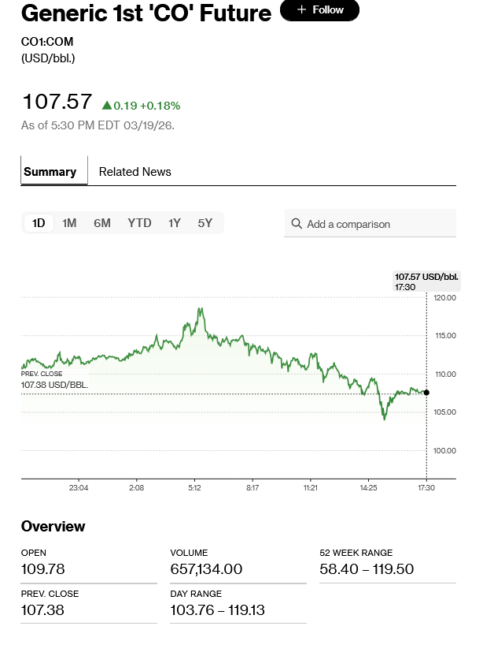

After Qatar LNG Plant Outage More Buyers Turn to US Suppliers
By Ruth Liao
March 19, 2026 at 10:47 PM GMT+2
An increasing number of purchasers and importers scrambling to secure liquefied natural gas turned to the US on Thursday after the latest attack on Qatar’s massive LNG complex further strained global supplies of the fuel.
Companies looking to import LNG have gone directly to US fuel sellers — either producers or offtakers with long-term contracts, according to people with knowledge of the matter. The sellers would have supply that’s slated for existing projects and ones under construction, said the people who asked not to be identified because the information is not public.
The US is the world’s largest exporter of LNG and looks to expand further with several facilities either planned or currently being built. Discussions for potential US LNG supply remain in early stages, and terms for any long-term contracts take time to be negotiated.
Shares of several US LNG producers rose on Thursday.
The Iran war and Qatar-plant outage has sent gas prices in Europe and Asia soaring, although prices in the US have only risen slightly as existing LNG facilities are running at or near capacity amid ample shale production.
Read More: Weeks of War Are Reshaping Global Gas Market for Years to Come (1)
The Iranian missile attacks that began late Wednesday on Qatar’s Ras Laffan complex, the largest LNG plant in the world, damaged two liquefaction trains. Repairs could take up to five years and require Qatar to declare long-term force majeure on its supply, with an estimated loss of $20 billion in annual revenue, according to a statement from QatarEnergy.
Production at the facility was halted in early March after an initial strike on the plant.

Ruth Liao is a reporter for Bloomberg News in Washington covering liquefied natural gas.

