About CIM:
For over 100 years, CIM has been the universal voice of marketing, championing our industry and its positive impact on organisations, economies and the wider society. Today, we play a more significant role than ever in supporting, developing and representing our members and the profession around the world. Always on top of the latest developments, we offer inspiring insights and thought leadership to generate transformative discussion and ideas.
On an individual level, marketers at every stage of their career find us a trusted and people-centred provider of clear guidance, training and professional qualifications – especially on their path to being accredited as a Chartered Marketer. If it carries a CIM stamp, it’s taken seriously: proof of the essential skills that boost long-term success for any business.
We’re at the forefront of all that’s exciting about marketing. Our services build careers and boost businesses. We continue to speak out for our industry, working alongside like-minded organisations to bring on the latest generations of talent and set professional standards for the entire marketing ecosystem.
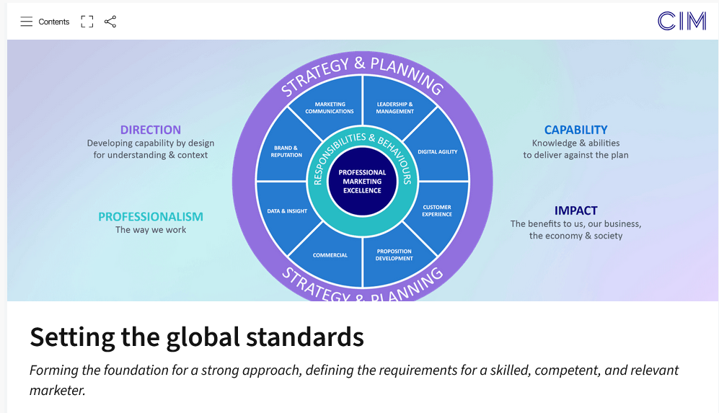
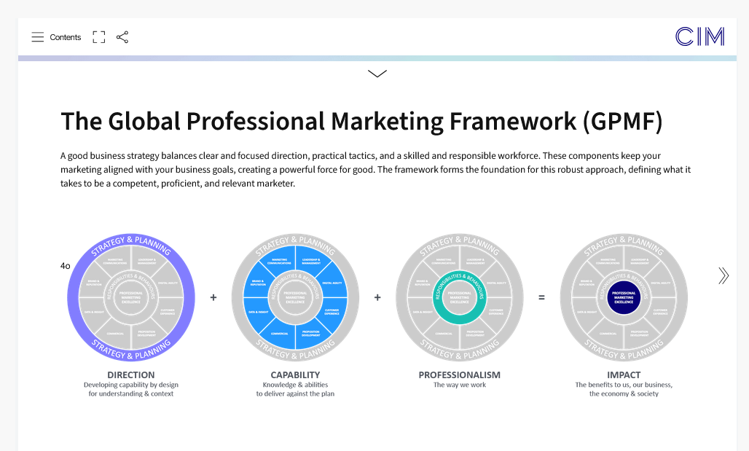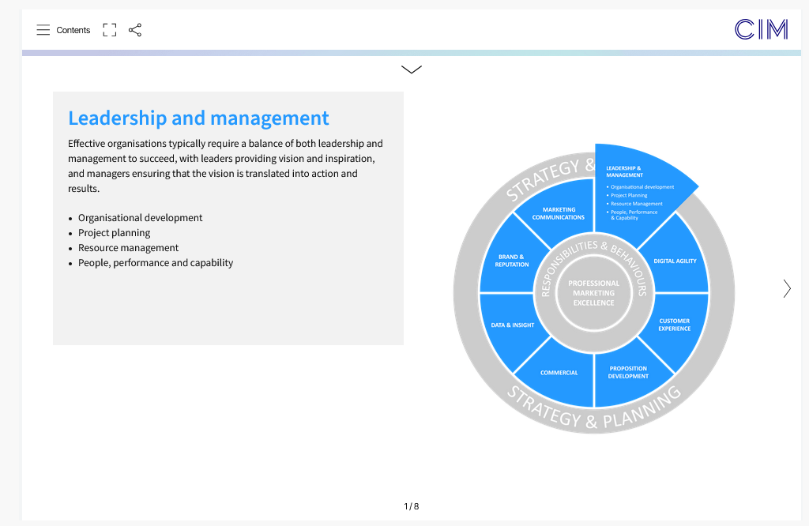

ΠΑΡΑΡΤΗΜΑ ΠΟΣΟΤΙΚΟΠΟΙΗΣΗΣ ΕΞΟΙΚΟΝΟΜΗΣΗΣ ΚΟΣΤΟΥΣ ΚΑΙ ΧΡΟΝΟΥ ΓΙΑ ΤΟΥΣ ΦΟΙΤΗΤΕΣ ΜΑΣ ΓΙΑ ΤΙΣ ΠΙΣΤΟΠΟΙΗΣΕΙΣ ΠΟΥ ΛΑΜΒΑΝΟΥΝ ΔΩΡΕΑΝ ΜΕΣΩ ΤΟΥ ΠΑΠΕΙ
Foundation Certificate in Professional & Digital Marketing
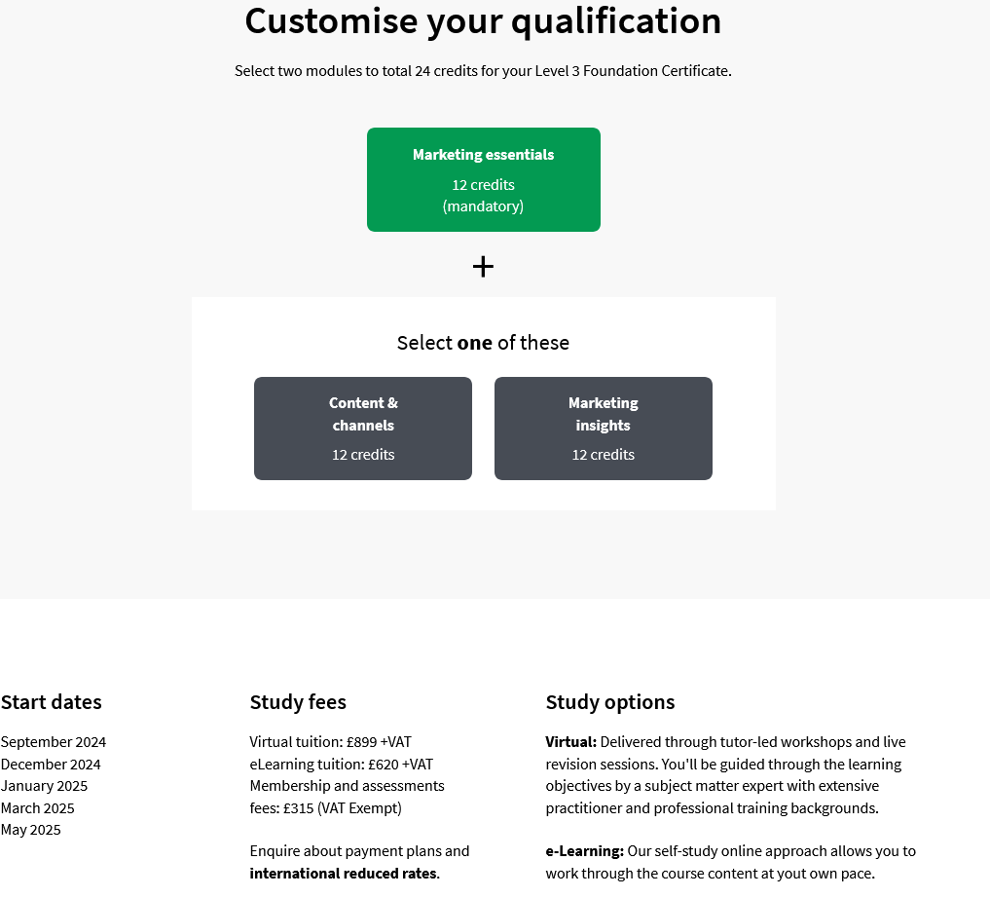
SAVINGS: £899 + £315 = £1.214
Minimum Time: 12 months

Certificate in Professional & Digital Marketing
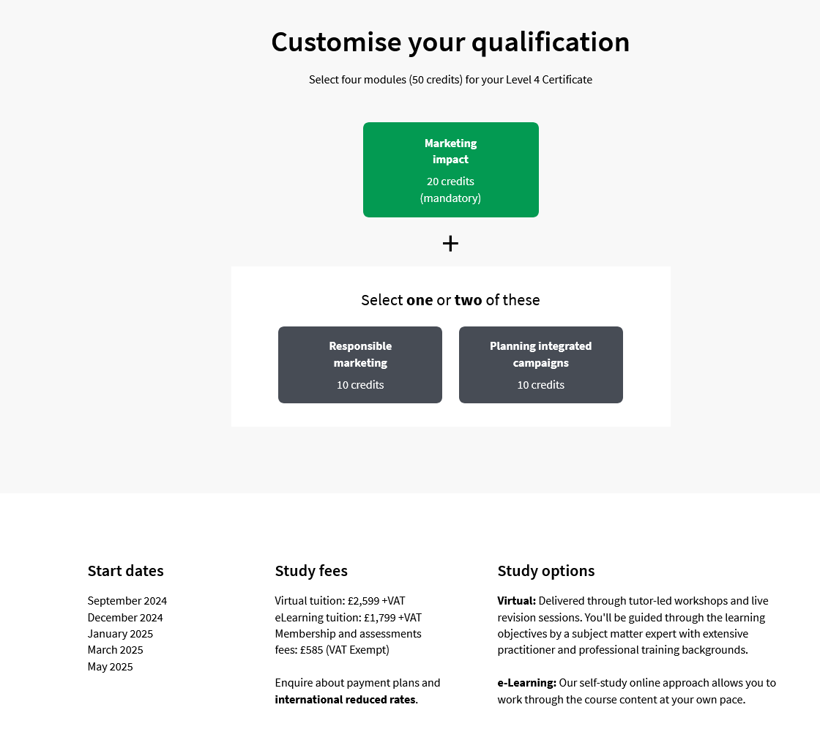
SAVINGS for the Certificate in Professional & Digital Marketing: £2,599 + £585 + VAT = £3.184
Minimum Time: incrementally 12 months after the Foundation

Diploma in Professional & Digital Marketing
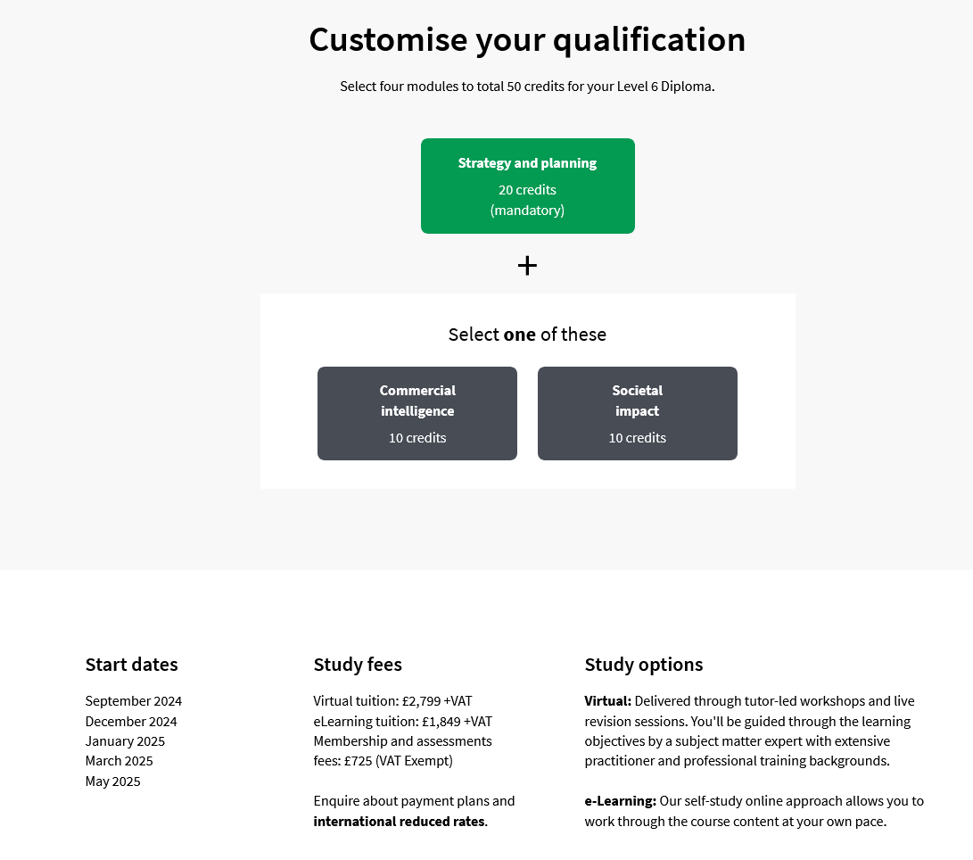
SAVINGS for Diploma in Professional & Digital Marketing: £2,799 + £725 +VAT = £3,524
Minimum Time: incrementally 12 months after the Certificate in Professional & Digital Marketing

TOTAL SAVINGS IN MONETARY TERMS: £1.214 + £3.184 + £3,524 = £7,922 * 1.18 (GBP/EUR) = €9,348 + VAT
TOTAL SAVINGS IN NON-MONETARY TERMS – TIME: 3 YRS
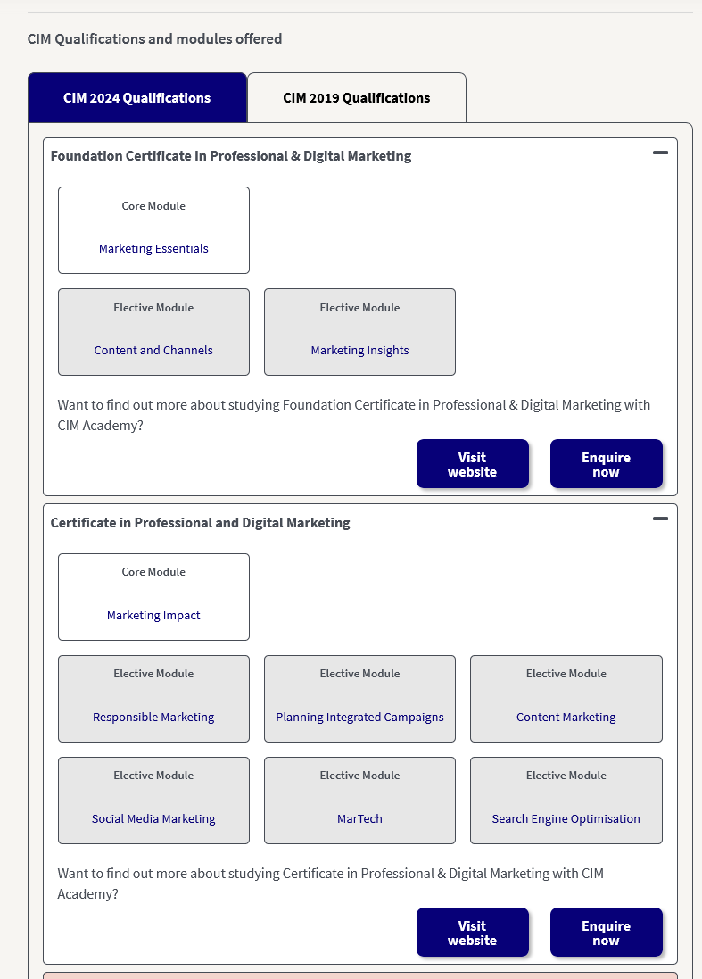
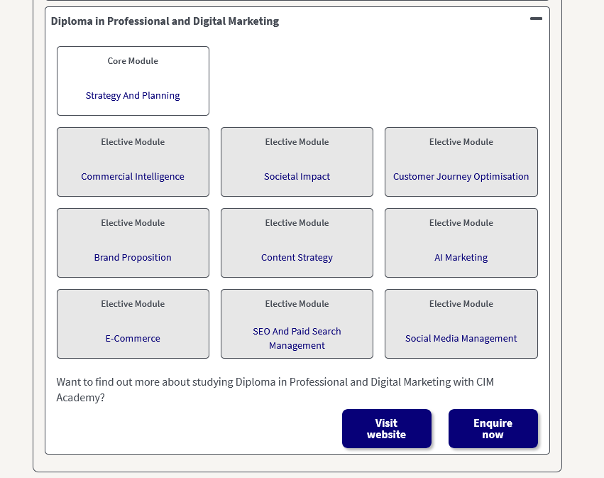
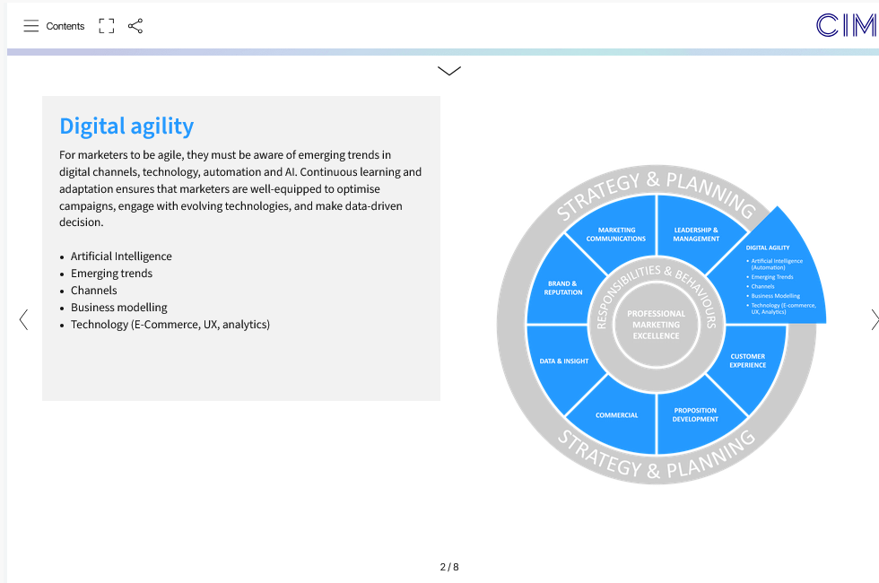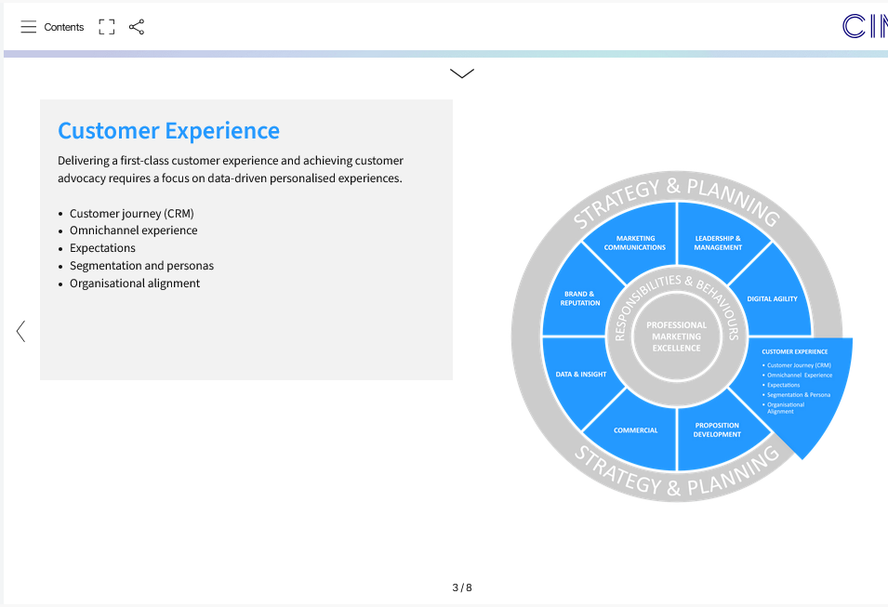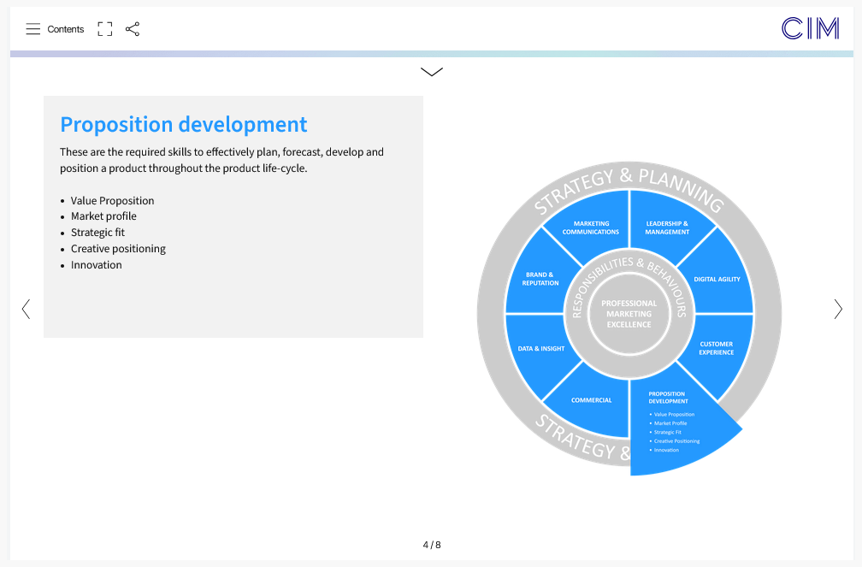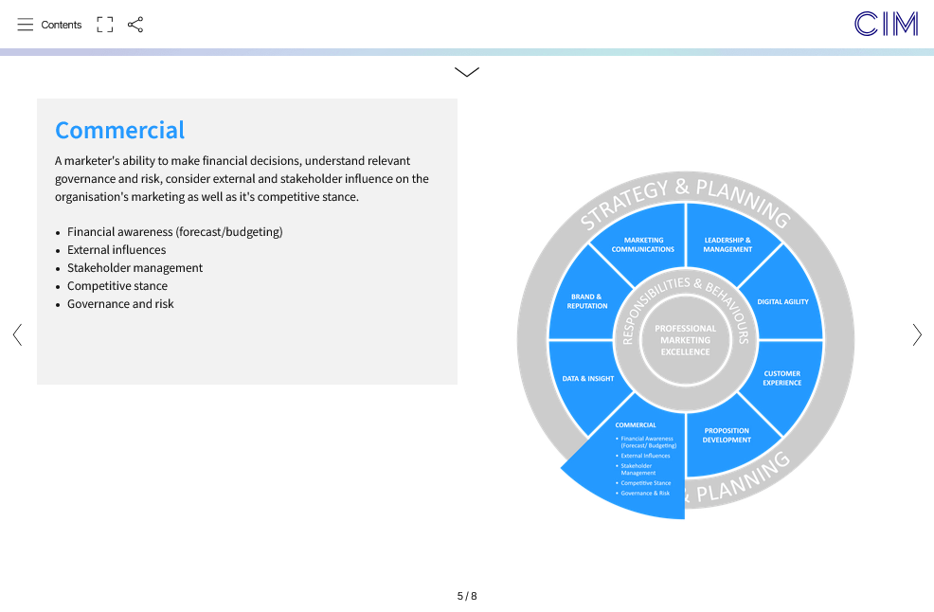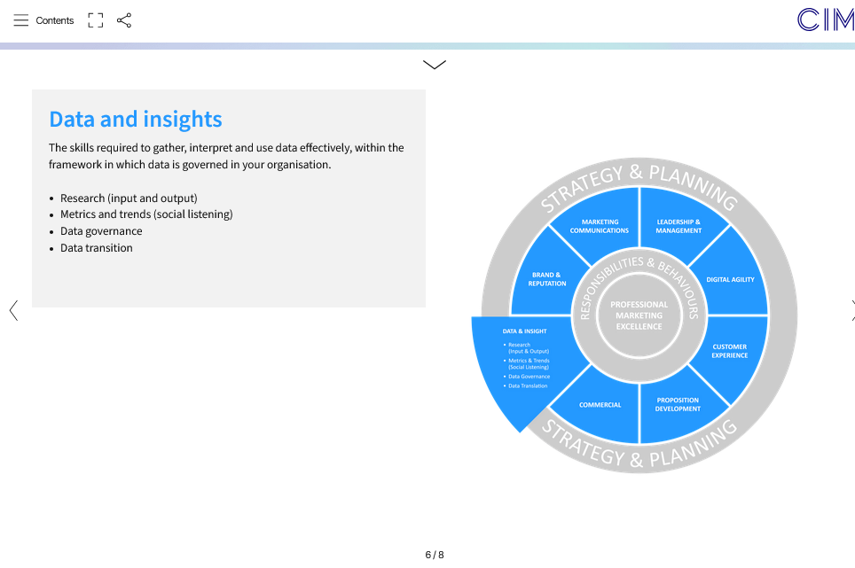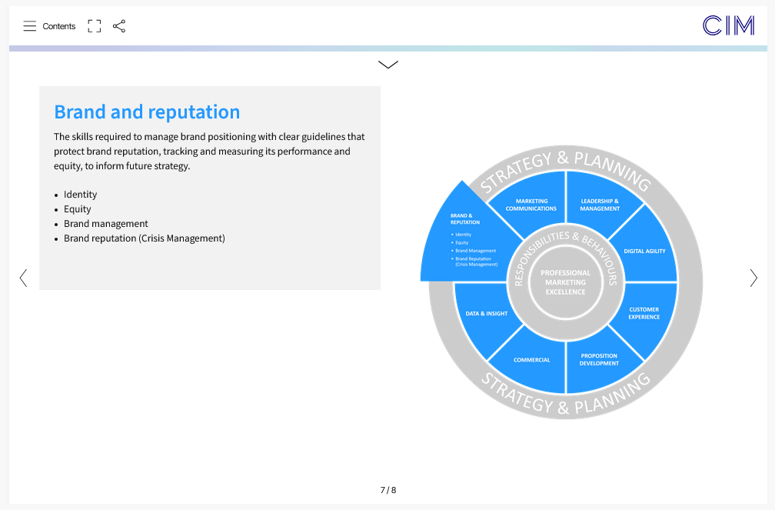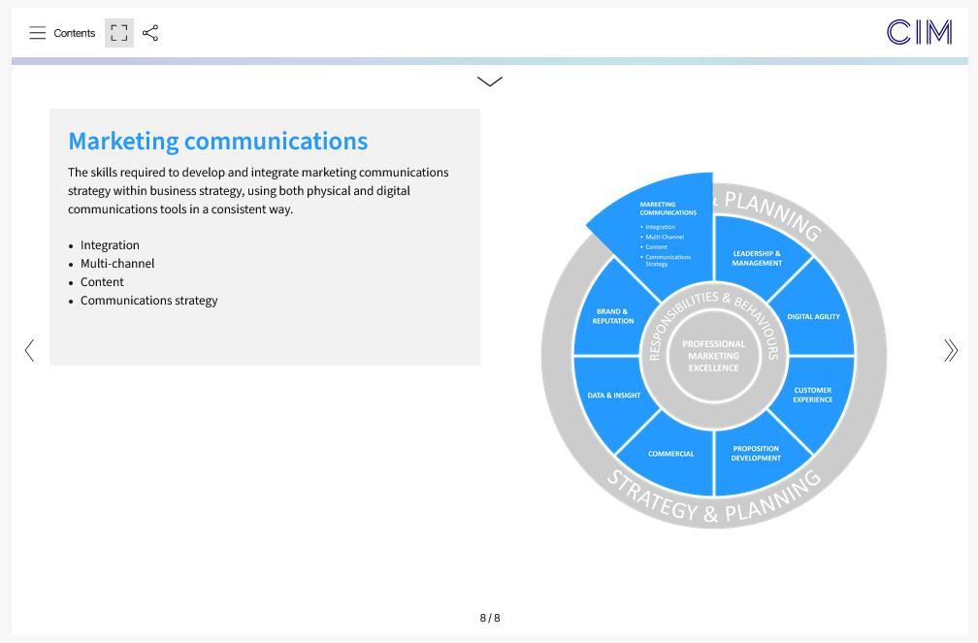
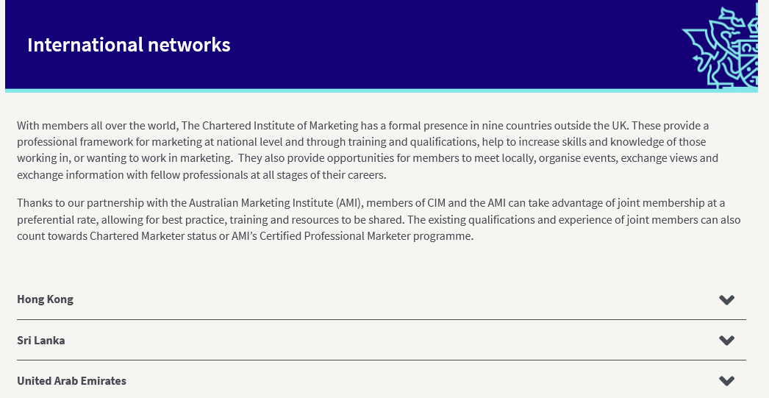
The Recognized CIM _ UNIPI Qualifications:
1. Fully Recognized for all Bachelor and Master Degrees’ Accredited Programs 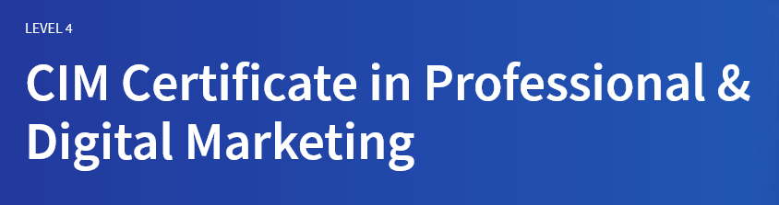

2. 50% exemption for the CIM Diploma
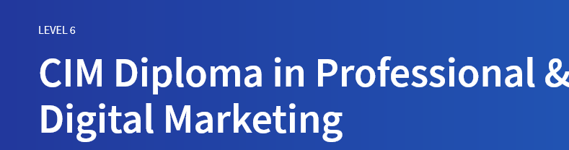
Students and graduates from 130+ CIM Accredited Degree Universities are gaining a professional marketing qualification by taking advantage of the exemptions CIM Accredited Degree provides.
Why study a CIM qualification?
- CIM offers a range of professionally recognised Marketing and Digital Marketing qualifications designed to develop core skills needed for modern marketers.
- Enhance your employability prospects – 60% of CIM graduates are more respected at work or given more responsibility. CIM Alumni Survey.
- Over a third of CIM graduates get promoted or receive a pay rise within 12 months of graduating. CIM Alumni Survey.
- Help to progress your career – 35% of marketing leaders have a CIM qualification – the most common after a university degree (46%). Hays, DNA of a Marketing Leader Report 2019).
For the Students’ Benefits

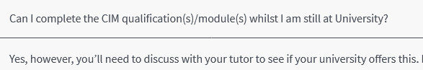
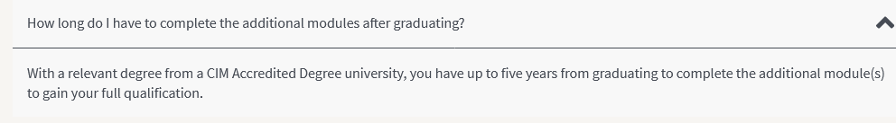
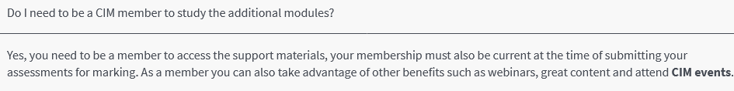
GBP 10,0 PER ANNUM

For UniPi accredited Programs by CIM is just GBP10 as UNIPI CIM Club Members instead of
GBP 65 p.a. + 