The Territorial and Maritime Dispute (Nicaragua v. Colombia) and Its Implications for Future Maritime Delimitations
in the Caribbean Sea and Elsewhere

Lawrence H. Martin and Yuri B. Parkhomenko

Abstract The Caribbean Sea is a geographically complex area with rich natural resources and important navigation routes. The coastal States have already achieved considerable progress in delimiting their maritime boundaries in this region. And yet many maritime boundaries still remain outstanding. As Caribbean States seek to resolve their ongoing maritime disputes, this chapter shows that they may find instructive guidance on how to reach equitable solutions in the unanimous judgment by the International Court of Justice in Territorial and Maritime Dispute (Nicaragua v. Colombia). This chapter analyzes the methodologies and reasoning the Court employed to draw the maritime boundary between the two Parties that allowed the coasts of both State to produce their effects in terms of maritime entitlements in a reasonable and mutually balanced way. Based on that analysis,

Lawrence H. Martin was part of the legal team representing the Republic of Nicaragua in the following cases: Territorial and Maritime Dispute (Nicaragua v. Colombia); Dispute regarding Navigational and Related Rights (Costa Rica v. Nicaragua); Certain Activities carried out by Nicaragua in the Border Area (Costa Rica v. Nicaragua); Construction of a Road in Costa Rica along the San Juan River (Nicaragua v. Costa Rica); Question of the Delimitation of the Continental Shelf between Nicaragua and Colombia (Nicaragua v. Colombia); Alleged Violations of Sovereign Rights and Maritime Spaces in the Caribbean Sea (Nicaragua v. Colombia); Delimitation in the Caribbean Sea and the Pacific Ocean (Costa Rica v. Nicaragua) and Land Boundary in the Northern Part of Isla Portillos (Costa Rica v. Nicaragua). The views and opinions expressed in this chapter are those of the authors and do not necessarily reflect the views and opinions of the Republic of Nicaragua.
Yuri B. Parkhomenko was part of the legal team representing the Republic of Nicaragua in the following cases: Territorial and Maritime Dispute (Nicaragua v. Colombia); Question of the Delimitation of the Continental Shelf between Nicaragua and Colombia (Nicaragua v. Colombia); Alleged Violations of Sovereign Rights and Maritime Spaces in the Caribbean Sea (Nicaragua v. Colombia); Delimitation in the Caribbean Sea and the Pacific Ocean (Costa Rica v. Nicaragua) and Land Boundary in the Northern Part of Isla Portillos (Costa Rica v. Nicaragua). The views and opinions expressed in this chapter are those of the authors and do not necessarily reflect the views and opinions of the Republic of Nicaragua. The authors are grateful to Robin Cleverly from Marbdy Consulting Limited for the maps he prepared for this chapter.

L.H. Martin (*) • Y.B. Parkhomenko (*)
Foley Hoag LLP, Washington, DC, USA
e-mail: LHM@foleyhoag.com; yparkhomenko@foleyhoag.com

© Springer International Publishing AG 2018
E. Sobenes Obregon, B. Samson (eds.), Nicaragua Before the International Court of Justice, DOI 10.1007/978-3-319-62962-9_6
113

114 L.H. Martin and Y.B. Parkhomenko

the chapter draws out conclusions on applicable law, methods of delimitation, relevant circumstances and treatment of islands that may become pertinent to future maritime delimitations in the Caribbean Sea and elsewhere.

Contents
- Introduction 114
- The Geographical Circumstances 117
- The Delimitation of the Maritime Boundary 119
  - Determining Relevant Coasts and Relevant Area 119
  - The Application of Delimitation Methodology 123
- Conclusions 138
References 139

- Introduction

Located between the landmasses of North and South America, the Caribbean Sea is an arm of the Atlantic Ocean partially enclosed to the north and east by the islands of the West Indies, and bounded to the south and west by South and Central America. The Caribbean Sea is one of the largest seas in the world, measuring approximately 2,754,000 km² (1,063,000 square miles). It is also one of the most geographically complex areas with rich natural resources and important navigation routes.
Within the Caribbean Sea region lie 9 continental States,¹ 12 island States,² 7 of which claim archipelagic status,³ and 16 islands linked to France,⁴ the Nether- lands,⁵ United Kingdom,⁶ and United States.⁷ The continental coasts of Venezuela, Colombia, and Panama frame the Caribbean Sea to the south and Costa Rica, Nicaragua, Honduras, Guatemala, Belize, and the Yucata´n Peninsula of Mexico

¹Mexico, Belize, Guatemala, Honduras, Nicaragua, Costa Rica, Panama, Colombia, and Venezuela.
²Antigua and Barbuda, Barbados, Cuba, Dominica, Dominican Republic, Grenada, Haiti, Jamaica, St Kitts and Nevis, St Vincent and Grenadines, St Lucia, and Trinidad and Tobago.
³Antigua and Barbuda, Dominican Republic, Grenada, St Kitts and Nevis, St Vincent and Grenadines, and Trinidad and Tobago.
⁴Guadeloupe, Martinique, and St. Barthe´lemy. The French Islands of Guadeloupe and Martinique are Overseas Departments. St. Barthe´lemy and the northern part of the French/Dutch island of St-Martin/Sint Maarten are French overseas collectivite´s.
⁵Aruba, Bonaire, Curac¸ao, Saba, St. Eustatius, and Sint Maarten. Aruba, Curac¸ao, and Sint Maarten are constituent countries forming the Kingdom of the Netherlands. Bonaire, St. Eustatius, and Saba are special municipalities of the Netherlands.
⁶Anguilla and British Virgin Islands, Cayman Islands, Montserrat, and Turks and Cacaos Islands. The islands are United Kingdom overseas territories.
⁷United States Virgin Islands and Puerto Rico. They are unincorporated United States territories.

The Territorial and Maritime Dispute (Nicaragua v. Colombia).. . 115

bound it to the west. To the north and east it is bounded by the Greater Antilles islands of Cuba, Hispaniola, Jamaica, and Puerto Rico and by the Lesser Antilles, consisting of the island arc that extends from the Virgin Islands in the north-east to the islands of Trinidad and Tobago, off the Venezuelan coast, in the south-east. The littoral states and islands are located in relation to each other in such a way that leaves no high seas areas (those beyond 200 nm) within the Caribbean Sea.
All coastal States in the Caribbean region, with the exception of Colombia and Venezuela, are parties to the 1982 United Nations Convention on the Law of the Sea.⁸ As regards claims to maritime jurisdiction, it was observed that the Caribbean region ‘boasts a near complete set of claims to 12 nautical miles territorial sea and 200 nautical miles exclusive economic zones limits measured from baselines along the coast.’⁹ A number of Caribbean States also made submissions to the United Nations Commission on the Limits of the Continental Shelf.¹⁰
In the Caribbean region, considerable progress has already been achieved in delimiting maritime boundaries either through negotiations¹¹ or by recourse to third-party compulsory procedures.¹² However, many maritime boundaries in this region still remain to be delimited (see Fig. 1 depicting delimited maritime bound- aries and calculated equidistance lines of outstanding delimitations).¹³ As States seek to resolve remaining maritime boundary disputes in this region, they may find

⁸The International Court of Justice held that the UNCLOS provisions governing delimitation of the exclusive economic zones and continental shelf, and the provisions setting forth the regime of islands are declaratory of customary international law. Territorial and Maritime Dispute (Nica- ragua v. Colombia), Merits, Judgment, ICJ Reports 2012, p. 624, paras 138–139 (hereinafter ‘Nicaragua v. Colombia (Merits)’).
⁹Freestone and Schofield (2015), p. 681 and pp. 677–679, Table 30.1 ‘Maritime claims in the Caribbean Sea and Gulf of Mexico’. Belize claims a territorial sea of 3 nautical miles in the Gulf of Honduras.
¹⁰These States include Bahamas, Barbados, France (on behalf of the French Antilles and French Guiana), Nicaragua, Suriname, and Trinidad and Tobago. See Submissions, through the Secretary- General of the United Nations, to the Commission on the Limits of the Continental Shelf, pursuant to article 76, paragraph 8, of the UNCLOS of 10 December 1982. Available at http://www.un.org/ Depts/los/clcs_new/commission_submissions.htm.
¹¹For comprehensive reports on completed and outstanding maritime delimitations in the Carib- bean sea, see Nweihed (1996), Dundas (2005) and Freestone and Schofield (2015).
¹²See Arbitration between Barbados and the Republic of Trinidad and Tobago, relating to the delimitation of the exclusive economic zone and the continental shelf between them, Award, 11 April 2006, RIAA, Vol. XXVII, pp. 147–251 (hereinafter ‘Barbados/Trinidad and Tobago (Award)’); Territorial and Maritime Dispute between Nicaragua and Honduras in the Caribbean Sea (Nicaragua v. Honduras), Judgment, ICJ Reports 2007, p. 659 (hereinafter ‘Nicaragua
v. Honduras (Judgment)’); Nicaragua v. Colombia (Merits), supra n. 8.
¹³See Nweihed (1996) and Dundas (2005).

116
L.H. Martin and Y.B. Parkhomenko

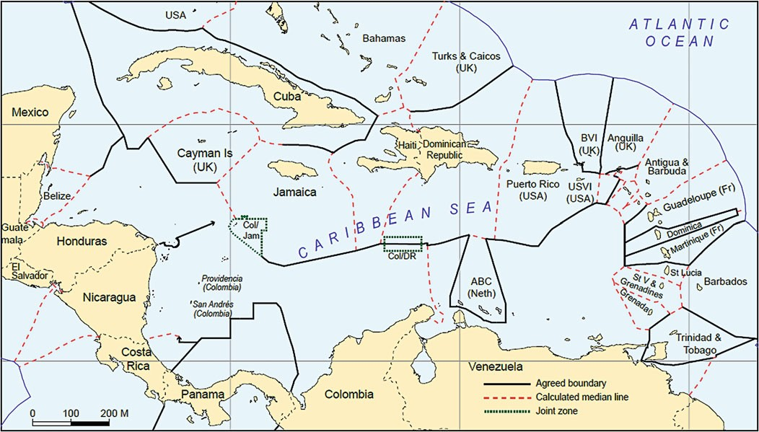

Fig. 1 The Caribbean: maritime boundaries

The Territorial and Maritime Dispute (Nicaragua v. Colombia).. . 117

instructive guidance on how to reach equitable solutions in the unanimous Judg- ment of the International Court of Justice (hereinafter ‘ICJ’ or ‘the Court’) in Territorial and Maritime Dispute (Nicaragua v. Colombia).¹⁴
The Judgment, in which the two distinguished ad hoc Judges appointed by the Parties joined with 14 sitting Judges to produce a rare 16-0 decision, in many ways constitutes the most interesting ruling to date by the Court on the delimitation of maritime boundaries. What makes the Judgment so notable is the Court’s ingenuity in applying different methods of maritime delimitation to achieve an equitable solution.
To appreciate the equitable nature of the delimitation solution unanimously fashioned by the Court, Sect. 2 describes the unique geographical circumstances of the case, and Sect. 3 discusses the methodologies and reasoning the Court employed to draw the maritime boundary between the Parties in the area within 200 nautical miles of Nicaragua’s coast.

- The Geographical Circumstances

The area within which this delimitation was carried out lies in the western Carib- bean Sea (see Fig. 2).¹⁵ The complexity of the geographic circumstances speaks for itself. The delimitation was not between the mainland coasts of two States; it was between Nicaragua’s long mainland coast—the dominant geographic feature in the area—and several small Colombian islands lying in front of the Nicaraguan coast, and far removed from Colombia’s mainland.
The largest of the islands, and the only ones that were populated, were San Andre´s, Providencia and Santa Catalina. San Andre´s is approximately 105 nautical miles from Nicaragua. Providencia and Santa Catalina are located some 47 nautical miles north-east of San Andre´s and approximately 125 nautical miles from Nica- ragua. All three islands are approximately 380 nautical miles from the mainland of Colombia.
All of the other insular features were tiny and uninhabitable. Starting from the south-west and moving to the north-east, there were the cays of Alburquerque, East- Southeast, Roncador and Serrana, and the bank of Quitasue~no.
Colombia considered the west-facing coasts of its islands and cays equivalent to a continuous coast stretching for over 100 nautical miles. In Colombia’s view, they blocked all access for Nicaragua to the substantial areas lying to the east of the islands and the 200 nautical-mile limit from Nicaragua’s coasts.
Nicaragua, on the other hand, argued that its extensive mainland coast generated entitlements to an exclusive economic zone (‘EEZ’) and continental shelf out to

¹⁴Nicaragua v. Colombia (Merits), supra n. 8.
¹⁵This figure corresponds to sketch-map No. 1 depicted in the Court’s Judgment at p. 16.

118
L.H. Martin and Y.B. Parkhomenko
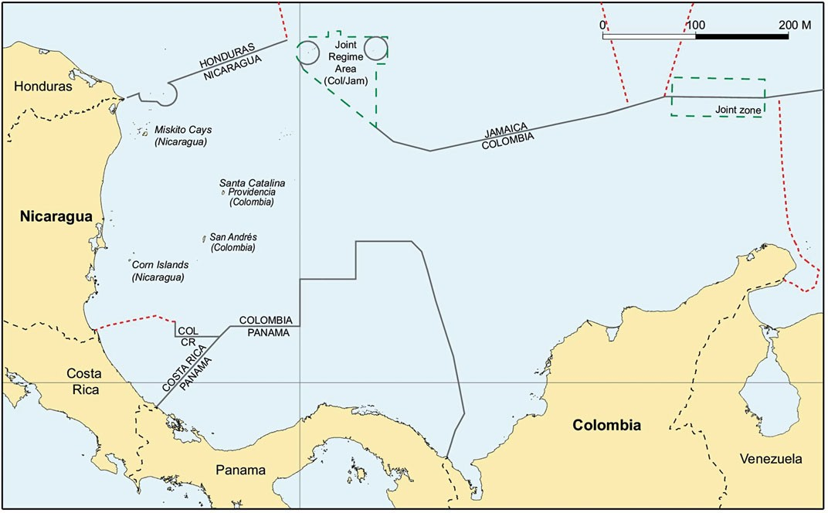

Fig. 2 Nicaragua/Colombia: the area to be delimited

The Territorial and Maritime Dispute (Nicaragua v. Colombia).. . 119

200 nautical-mile line, which should not be cut off by Colombia’s small, widely dispersed islands.¹⁶

- The Delimitation of the Maritime Boundary

The task of the Court was to equitably delimit the maritime area within 200 nautical miles of Nicaragua’s coast, where both Nicaragua and Colombia had overlapping EEZ and continental shelf entitlements.¹⁷ As its first step, the Court identified the Parties’ ‘relevant coasts;’ that is, the coasts that generated maritime entitlements in the area to be delimited, as well as the ‘relevant area’ where these entitlements overlapped and delimitation was required. The Court then proceeded to apply its now-customary three-step delimitation methodology.

  - Determining Relevant Coasts and Relevant Area

The maritime entitlements of a coastal State are based on the principle that the land dominates the sea through the projection of its coast seaward.¹⁸ It is therefore necessary in each delimitation case to identify the coasts that are relevant to the

¹⁶The case was governed by customary international law rather than the 1982 UNCLOS because, while Nicaragua is a party to UNCLOS, Colombia is not. However, as the Court has made clear in prior cases, UNCLOS and customary law are similar in regard to the entitlements of coastal States and the delimitation of maritime boundaries within 200 nautical miles of the coast (see e.g., Maritime Delimitation and Territorial Questions between Qatar and Bahrain (Qatar v. Bahrain), Merits, Judgment, ICJ Reports 2001, p. 91, paras 167 et seq. (hereinafter ‘Qatar v. Bahrain (Merits)’) and Maritime Delimitation in the Black Sea (Romania v. Ukraine), Judgment, ICJ Reports 2009, pp. 101–103, para 120 (hereinafter ‘Romania v. Ukraine (Judgment)’)) Under both the Convention and customary law, coastal States are entitled to declare a territorial sea of up to 12 nautical miles from their coastal baselines, and an exclusive economic zone and continental shelf of up to 200 nautical miles; and, where the entitlements of opposite or adjacent coastal States overlap, delimitation is to be effected either by agreement of the parties, or in a manner that produces an equitable solution (Articles 3, 57, 74, 76 and 83 of the 1982 UNCLOS).
¹⁷In addition to delimiting the continental shelf within 200 nautical miles between the Nicaraguan mainland coast and Colombian islands, Nicaragua also requested the Court to delimit the conti- nental shelf between the mainland coasts of both States, arguing that Nicaragua’s continental margin extends beyond 200 nautical miles and overlaps with Colombia’s 200-nautical mile entitlement to the continental shelf as measured from Colombia’s mainland coast. Because at the time of those proceedings Nicaragua had yet to make its final submission to the CLCS in respect of the continental shelf beyond 200 nautical miles, the Court declined Nicaragua’s request. The delimitation of that area is now the subject of a separate case over which the Court recently ruled it has jurisdiction. See Question of the Delimitation of the Continental Shelf between Nicaragua and Colombia beyond 200 Nautical Miles from the Nicaraguan Coast (Nicaragua
v. Colombia), Preliminary Objections, Judgment of 17 March 2016.
¹⁸See Romania v. Ukraine (Judgment), supra n. 16, p. 89, para 77; Nicaragua v. Colombia
(Merits), supra n. 8, p. 674, para 140.

120 L.H. Martin and Y.B. Parkhomenko

delimitation; namely, ‘those coasts the projections of which overlap, because the task of delimitation consists in resolving the overlapping claims by drawing a line of separation of the maritime areas concerned.’¹⁹
As the Court explained, identification of the relevant coasts is necessary for two different but closely related legal reasons: first, to determine where overlapping entitlements exist and, second, to check in the final stage of delimitation whether any disproportionality exists when the ratios of the coastal lengths of each State are compared with the ratios of the maritime areas falling on either side of the delimitation line.²⁰
For Nicaragua, the Court found that the relevant coast was its entire Caribbean coast, with the exception of the short stretch of coast near Punta de Perlas that faces due south and thus does not project into the area of overlapping entitlements. The Court also considered that Nicaragua’s entitlement to a 200 nautical-mile EEZ and continental shelf had to be measured from the islands fringing the Nicaraguan coast, the Corn Islands in the south and the Miskitos Cays in the north, because ‘fringing islands’ are an integral part of a mainland coast. At the same time, the Court found that those islands did not add to the length of Nicaragua’s relevant coast, because their east-facing coasts are parallel to the mainland.²¹
To identify Colombia’s relevant coast, the Court looked only to the insular features facing Nicaragua’s coast, since only those islands generated maritime entitlements that overlapped with Nicaragua’s.²² The relevant Colombian coast thus consisted of the coasts of San Andre´s, Providencia and Santa Catalina Islands, and Alburquerque, East-Southeast, Roncador and Serrana Cays.
The Court accepted Colombia’s argument that the entire coastline of each of these features, not merely the coasts facing Nicaragua, had to be taken into account because islands generate radial projections, which also extended to the east of those islands. The Court disregarded Quitasue~no, a small rock, in determining Colombia’s relevant coast because its size is so small that it ‘cannot make any difference to the length of Colombia’s coast.’²³
The Court found that the lengths of the relevant coasts were 531 km for Nicaragua and 65 km for Colombia, a ratio of approximately 8.2:1 in favor of Nicaragua.²⁴
Once the relevant coasts were established, the next step was to determine the relevant area, which is the area to be delimited, consisting of that part of the

¹⁹Nicaragua v. Colombia (Merits), supra n. 8, pp. 674–675, para 141.
²⁰Romania v. Ukraine (Judgment), supra n. 16, para 78; Nicaragua v. Colombia (Merits), supra
n. 8, pp. 674–675, para 141.
²¹Nicaragua v. Colombia (Merits), supra n. 8, p. 678, para 145.
²²Because Colombia’s mainland coast is located more than 400 nautical miles away from Nicaragua’s coast, maritime entitlements it generates could not overlap with Nicaragua’s, and thus the Colombian mainland coast was not a relevant coastline for the delimitation in that case.
²³Nicaragua v. Colombia (Merits), supra n. 8, p. 680, para 152.
²⁴Ibid., p. 678, para 145 and p. 680, para 153.

The Territorial and Maritime Dispute (Nicaragua v. Colombia).. . 121

maritime space in which the potential maritime entitlements generated by the relevant coastlines of the Parties overlap.²⁵
Nicaragua and Colombia disagreed on the extent of the relevant area. For Nicaragua, the relevant area necessarily included all of the maritime space lying between its mainland coast and Colombia’s islands, as well as the area east of the islands all the way out to the 200 nm limits from Nicaragua’s coast.
Colombia, for its part, tried to limit the relevant area to only the space located between Nicaragua’s coast and Colombia’s islands. In this way, Colombia hoped to reserve all of the space east of its islands (but still within 200 nm of Nicaragua’s coast) for itself. In Colombia’s view, its mid-sea islands effectively constituted a wall that should prevent Nicaragua from extending its maritime jurisdiction to their east. (See Fig. 3).²⁶
Colombia’s argument contradicted a long line of case law, which included not only the Court’s jurisprudence,²⁷ but also precedent from other international courts and arbitral tribunals, to the effect that small islands should not block the seaward projection of mainland coasts or otherwise cut off the maritime entitlements generated by those coasts.²⁸ As the Court explained, Nicaragua’s coast, including fringing islands, projects maritime entitlements out at least to 200 nautical miles. This entitlement extends east of Colombia’s islands, where it overlaps with Colombia’s competing entitlements derived from those islands. The Court thus determined that ‘the relevant area extends from the Nicaraguan coast to a line in the east 200 nautical miles from the baselines from which the breadth of Nicaragua’s territorial sea is measured.’²⁹
To avoid affecting the interests of third States to the north and to the south, the Court excluded from the relevant area maritime areas where Nicaragua’s and

²⁵Ibid., p. 683, paras 158–159.
²⁶This figure corresponds to sketch-map No. 5 depicted in the Court’s Judgment at p. 54.
²⁷See e.g. Delimitation of the Maritime Boundary in the Gulf of Main Area (Canada/United States of America), Judgment, ICJ Reports 1984, pp. 329–330, para 201 (hereinafter ‘Gulf of Maine (Judgment)’); Continental Shelf (Libyan Arab Jamahiriya v. Malta), Judgment, ICJ Reports 1985,
p. 46, para 64 (hereinafter ‘Libya/Malta (Judgment)’); Continental Shelf (Tunisia/Libyan Arab Jamahiriya), Judgment, ICJ Reports 1982, pp. 88–89, paras 128–129 (hereinafter ‘Tunisia/Libya (Judgment)’); Romania v. Ukraine (Judgment), supra n. 16, pp. 109–110, para 149.
²⁸See e.g. Delimitation of the Continental Shelf between France and the United Kingdom, Decision, 30 June 1977, RIAA, Vol. XVIII, p. 93, para 196 and p. 94, para 199 (hereinafter ‘Anglo-French Continental Shelf (1977 Award)’); Dubai/Sharjah Border Arbitration, Award, 19 October 1981, ILR, Vol. 91, pp. 676–677, paras 263 and 265 (hereinafter ‘Dubai/Sharjah (Merits)’); Delimitation of Maritime Areas between Canada and France (St. Pierre et Miquelon), Decision, 10 June 1992, ILM, Vol. 31, pp. 1169–1170, paras 67, 69 and 70 (hereinafter ‘St. Pierre and Miquelon (Award)’); Limits of the Offshore Areas between Newfoundland and Labrador and Nova Scotia, Second Phase, Award, 26 March 2002, ILR, Vol. 128, paras 5.14–5.15 (hereinafter ‘Newfoundland/Nova Scotia (Award)’) and Dispute concerning Delimitation of the Maritime Boundary between Bangladesh and Myanmar in the Bay of Bengal, Judgment, 14 March 2012, paras 317–319 (hereinafter ‘Bangladesh/Myanmar (Judgment)’). See also Bowett (1993), p. 151.
²⁹Nicaragua v. Colombia (Merits), supra n. 8, p. 683, para 159.

122 L.H. Martin and Y.B. Parkhomenko
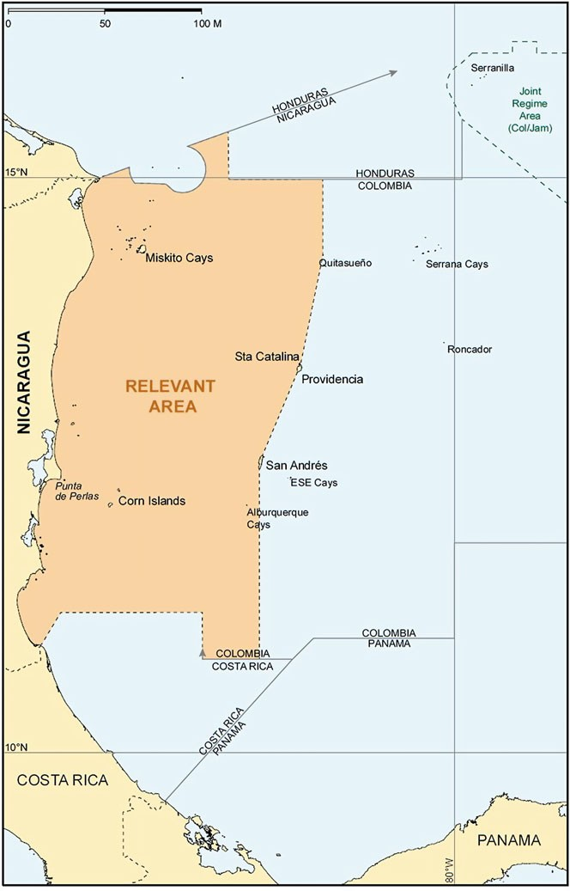
Fig. 3 The relevant area according to Colombia

The Territorial and Maritime Dispute (Nicaragua v. Colombia).. . 123

Colombia’s entitlements overlapped areas claimed by Jamaica, Panama and Costa Rica in agreements those States had previously reached with Colombia. Thus defined, the relevant area measured approximately 209,280 km² ³⁰ (see Fig. 4, depicting the relevant area according to the Court).³¹

  - The Application of Delimitation Methodology

In its prior decisions, the Court established a three-step method to delimit overlapping entitlements in the EEZ and continental shelf.³²
In the first stage, a provisional delimitation line is constructed using techniques that are geometrically objective and appropriate for the geography of the area. This task consists of plotting a provisional equidistance line, unless the use of an equidistance line is not feasible or is otherwise inappropriate.³³
In the second stage, the Court considers whether there are any ‘relevant circum- stances’ that may call for an adjustment or shifting of the provisional equidistance line so as to achieve an equitable delimitation. If the Court concludes that such circumstances are present, it may adjust or shift the equidistance line as necessary to take account of those circumstances.³⁴
Where the relevant circumstances so require, the provisional equidistance line may be abandoned altogether, and other techniques, such as the use of an angle bisector or the drawing of enclaves around isolated islands, may be employed to effect an equitable delimitation.³⁵

³⁰More specifically, the Court concluded that the limit of the relevant area in the north follows the maritime boundary between Nicaragua and Honduras, laid down in the Court’s Judgment of 8 October 2007, until it reaches latitude 16◦ north. It then continues due east until it reaches the boundary of the Colombia-Jamaica ‘Joint Regime Area’. From that point, it follows the boundary
of that Area, skirting a line 12 nm from Serranilla, until it intersects with the line 200 nm from Nicaragua. In the south, the boundary of the relevant area begins in the east at the point where the line 200 nm from Nicaragua intersects with the boundary line agreed between Colombia and Panama. It then follows the Colombia-Panama line to the west until it reaches the line agreed between Colombia and Costa Rica. It follows that line westwards and then northwards, until it intersects with a hypothetical equidistance line between the Costa Rican and Nicaraguan coasts. Nicaragua v. Colombia (Merits), supra n. 8, p. 686, paras 164–165.
³¹This figure corresponds to sketch-map No. 7 depicted in the Court’s Judgment at p. 64.
³²Libya/Malta (Judgment), supra n. 27, p. 46, para 60; Romania v. Ukraine (Judgment), supra
n. 16, pp. 101–103, paras 115–122.
³³Romania v. Ukraine (Judgment), supra n. 16, p. 101, para 116; Nicaragua v. Honduras
(Judgment), supra n. 12, p. 745, para 281.
³⁴Libya/Malta (Judgment), supra n. 27, p. 47, para 63; Maritime Delimitation in the Area between Greenland and Jan Mayen (Denmark v. Norway) Judgment, ICJ Reports 1993, pp. 79–81, paras 91–92 (hereinafter ‘Jan Mayen (Judgment)’).
³⁵Romania v. Ukraine (Judgment), supra n. 16, pp. 101–103, paras 119–121; Nicaragua
v. Honduras (Judgment), supra n. 12, p. 745, para 281; Delimitation of the maritime boundary between Guinea and Guinea-Bissau, Decision, 14 February 1985, ILR, Vol. 77, p. 635.

124 L.H. Martin and Y.B. Parkhomenko
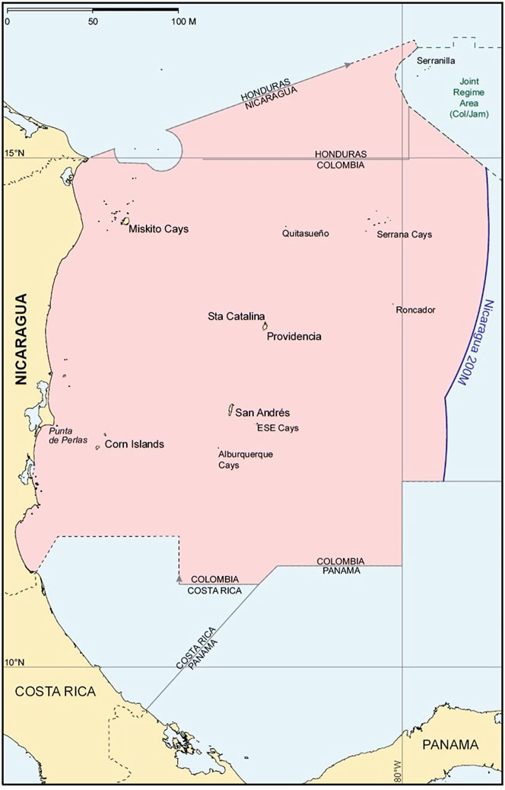
Fig. 4 The relevant area according to the Court

The Territorial and Maritime Dispute (Nicaragua v. Colombia).. . 125

In the third and final stage, a ‘disproportionality’ test is conducted to verify that the line the results from the application of the first two steps does not lead to any marked disproportion, as determined by comparing the ratio of the Parties’ relevant coastal lengths and the resulting ratio of their maritime areas. In the absence of a substantial disproportionality between these two ratios, the delimitation will be deemed equitable.³⁶
The three-stage process, as the Court has repeatedly emphasized, ‘is not, of course, to be applied in a mechanical fashion and [.. .] it will not be appropriate in every case to begin with a provisional equidistance/median line.’³⁷ The question of whether it was appropriate to start with an equidistance line in the geographical circumstances of this case took center stage. Colombia insisted on the application of a strict, unmodified equidistance line between the west-facing coasts of its islands and the Nicaraguan coastline, including the fringing islands.³⁸ Its proposed bound- ary line is depicted in Fig. 5.³⁹
Nicaragua saw that approach as inherently inequitable: the line so drawn would cut off the eastward projection of Nicaragua’s extensive mainland coast and deprive it of any maritime entitlements east of the hypothetical ‘line’ formed by Colombia’s small islands, thus allocating some three quarters of the relevant area to Colombia, and confining Nicaragua to a narrow band of sea extending only some 55 nautical miles from its mainland (and even less from its fringing islands) despite its much longer coastline. Given these circumstances, Nicaragua argued that the appropriate provisional delimitation line should be enclaves drawn around all of Colombia’s islands (12 nautical miles for the larger islands, 3 nm for the small cays).
The Court decided not to abandon the standard methodology it regularly employed in prior cases, and commenced the delimitation process, as has become customary, by constructing a provisional equidistance line between Nicaragua’s coast and Colombia’s islands (as Colombia had proposed).
This approach was criticized by some Judges, including Judge Xue, who in her separate Declaration stated that she did not believe the Court should have wedded itself to a provisional equidistance line, which (as discussed below) it then had to modify substantially to achieve an equitable delimitation. Nevertheless, Judge Xue and the other Judges uncomfortable with the Court’s reliance on this approach agreed that the result ultimately reached by the Court was an equitable one. In particular, all of the judges agreed that the Parties had overlapping entitlements to the east of Colombia’s islands, from which area Nicaragua could not be excluded, and that the considerable disparity of coastal lengths had to be taken into account in determining the course of the maritime boundary. As reflected in the Judgment, however, a majority concluded that those factors were to be considered in the

³⁶Romania v. Ukraine (Judgment), supra n. 16, p. 103, para 122.
³⁷Nicaragua v. Colombia (Merits), supra n. 8, p. 696, para 194; Nicaragua v. Honduras (Judgment), supra n. 12, p. 741, para 272 and Romania v. Ukraine (Judgment), supra n. 16, p. 101, para 116.
³⁸Nicaragua v. Colombia (Merits), supra n. 8, p. 700, para 206.
³⁹This figure corresponds to sketch-map No. 3 depicted in the Court’s Judgment at p. 49.

126 L.H. Martin and Y.B. Parkhomenko
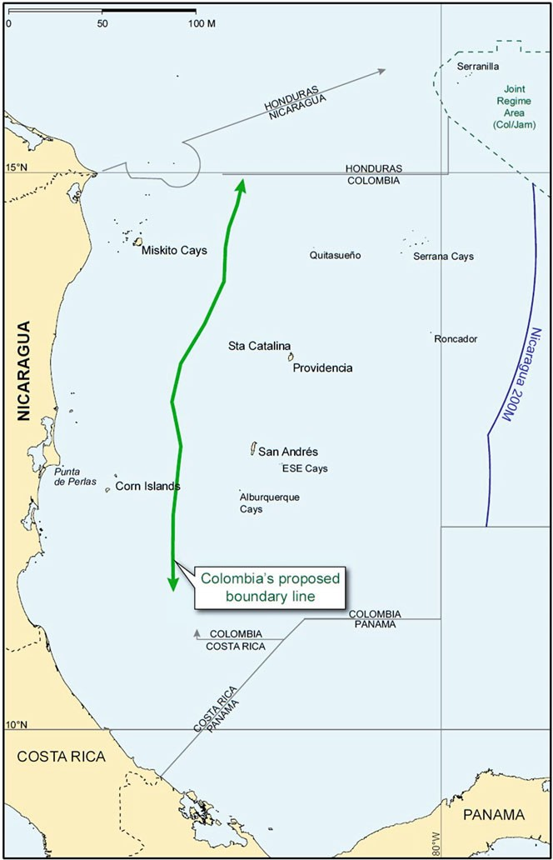

Fig. 5 The boundary according to Colombia

The Territorial and Maritime Dispute (Nicaragua v. Colombia).. . 127

second stage of the delimitation process, and ‘do not justify discarding the entire methodology and substituting an approach in which the starting-point is the con- struction of enclaves for each island, rather than the construction of a provisional median line.’⁴⁰
At the same time, the Judgment emphasizes that following the three-step approach and starting with a provisional equidistance line ‘does not preclude very substantial adjustment to, or shifting of, the provisional line in an appropriate case, nor does it preclude the use of enclaving in those areas where the use of such a technique is needed to achieve an equitable result.’⁴¹ The Court thus proceeded in accordance with its standard three-step method as described in detail below.

    - Construction of the Provisional Median Line

Consistent with its prior decisions, the Court constructed a provisional equidistance line between the Nicaragua’s mainland (including fringing islands) and Colombia’s islands, by reference to the base points it considered appropriate.⁴²
For the Nicaraguan coast, the Court used base points located on Edinburgh Reef, Muerto Cay, the Miskito Cays, Ned Thomas Cay, Roca Tyra, Little Corn Island and Great Corn Island. For the Colombian coast, it placed base points on Santa Catalina, Providencia and San Andre´s Islands and on Alburquerque Cay. At the same time, it decided that Quitasuen~o, Serrana and Low Cay (where Colombia had proposed the placement of base points) were too insignificant to be used in the construction of the provisional equidistance line.
The ICJ’s unwillingness to place base points on tiny insular features goes back at least as far as the Gulf of Maine case, decided more than 30 years ago. In that Judgment, a Chamber of the Court warned of ‘the potential disadvantages inherent in any method which takes tiny islands, uninhabited rocks or low-tide elevations, sometimes lying at a considerable distance from terra firma, as a basepoint for the drawing of a line intended to effect an equal division of a given area.’⁴³ The Chamber expressly objected to ‘making a series of such minor features the very basis for the determination of the dividing line, or for transforming them into a succession of basepoints for the geometrical construction of the entire line.’⁴⁴
Similarly, in Libya/Malta, the Court ruled that ‘the equitableness of an equidistance line depends on whether the precaution is taken of eliminating the disproportionate effect of certain “islets, rocks and minor coastal projections.”’⁴⁵

⁴⁰Nicaragua v. Colombia (Merits), supra n. 8, p. 697, para 196.
⁴¹Ibid.
⁴²Ibid., p. 698, para 200 (the Court reaffirmed that it ‘should not base itself solely on the choice of base points made’ by one of the disputing parties; it ‘must [.. .] select base points by reference to the physical geography of the relevant coasts’).
⁴³Gulf of Maine (Judgment), supra n. 27, pp. 329–330, para 201.
⁴⁴Ibid.
⁴⁵Libya/Malta (Judgment), supra n. 27, p. 48, para 64.

128 L.H. Martin and Y.B. Parkhomenko

The Court thus found it equitable not to take account of a small Maltese islet, Filfla, in the construction of the provisional median line.
The Court similarly held in Romania v. Ukraine that it was inappropriate to place any base point on Ukraine’s tiny Serpents’ Island because it lay alone and at a distance of some 20 nautical miles from the mainland coast of Ukraine, and its use in constructing the equidistance line ‘would amount to grafting an extraneous element onto Ukraine’s coastline; the consequence would be a judicial refashioning of geography, which neither the law nor practice of maritime delimitation authorizes.’⁴⁶
Building upon its prior decisions, the Court reasoned that the same consider- ations applied to Colombia’s Quitasue~no, Serrana and Low Cay. For example, Quitasuen~o, in addition to being a tiny feature, lies considerably north of Santa Catalina, and its use in the construction of the provisional median line would have pushed that line significantly closer to Nicaragua and blocked the seaward projec- tion of Nicaragua’s coast north of the main islands.
Serrana, another tiny feature, was also discounted because it lies at a consider- able distance from any of the other Colombian islands, and placing a base point on it would have produced a marked effect upon the course of the provisional equidistance line out of all proportion to its size and significance.
The same conclusion was reached in regard to Low Cay, a small, uninhabited feature near Santa Catalina. While the Court disregarded these minor features in constructing the provisional equidistance line, it ruled that each was still entitled to a 12-nm territorial sea.
The provisional equidistance line constructed from the selected base points is depicted in Fig. 6.⁴⁷

    - Consideration of the Relevant Circumstances

The Parties invoked different considerations they deemed relevant to the achieve- ment of an equitable solution: the marked disparity in the lengths of the relevant coasts, the cut-off effects of Colombia’s islands, and other considerations such as the conduct of the parties, security and law enforcement interests, equitable access to natural resources, and delimitations already effected in the area with third States. They drew opposite conclusions from their analyses of those considerations, how- ever. Colombia argued that the provisional equidistance line afforded an equitable solution and therefore required no adjustment whatsoever. Nicaragua responded that the inequity resulting from that line called for an entirely different approach; namely the enclaving of all of Colombia’s islands. The Court evaluated all of these factors to determine whether they called for adjustment (or abandonment) of the provisional equidistance line.

⁴⁶Romania v. Ukraine (Judgment), supra n. 16, pp. 109–110, para 149.
⁴⁷This figure corresponds to sketch-map No. 8 depicted in the Court’s Judgment at p. 76.

The Territorial and Maritime Dispute (Nicaragua v. Colombia).. . 129
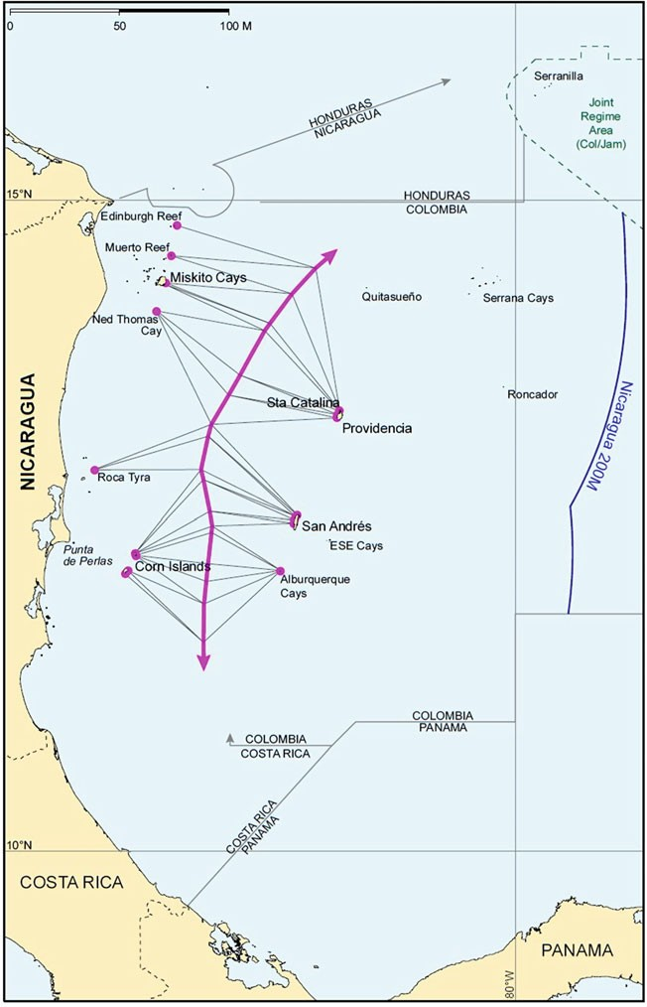
Fig. 6 The construction of the provisional equidistance line by the Court

130 L.H. Martin and Y.B. Parkhomenko

      - Disparity in the Lengths of the Relevant Coasts

Nicaragua argued that the significant disparity in the length of the Parties’ relevant coasts must be taken into account in order to arrive at an equitable solution. Colombia naturally sought to downplay this factor.
The Court’s jurisprudence establishes that, while ‘the respective length of coasts can play no role in identifying the equidistance line which has been provisionally established,’⁴⁸ it is nevertheless true that ‘a substantial difference in the lengths of the parties’ respective coastlines may be a factor to be taken into consideration in order to adjust or shift the provisional delimitation line.’⁴⁹ Indeed, in all prior cases where disparities in the lengths of coasts were particularly marked, the Court treated that fact as a relevant circumstance requiring an adjustment to the provi- sional equidistance line.
In the Jan Mayen case, for example, the Court found that the disparity between the lengths of the coasts of Norway’s Jan Mayen Island and Greenland (approxi- mately 9:1) constituted a ‘special circumstance’ requiring modification of the provisional equidistance line in favor of Greenland (Denmark), by moving it closer to the coast of Jan Mayen, to avoid inequitable results.⁵⁰ In Libya/Malta, the Court similarly found that the difference in the lengths of the relevant coasts of Malta and Libya (by a ratio 8:1) ‘is so great as to justify the adjustment of the median line.’⁵¹ Drawing on these decisions, the Court found that the coastal length ratio of 8.2:1
in favor of Nicaragua ‘is undoubtedly a substantial disparity’ that ‘requires an adjustment or shifting of the provisional line, especially given the overlapping maritime areas to the east of the Colombian islands.’⁵² The Court noted that a maritime boundary following the provisional equidistance line, as Colombia pro- posed, would have left Colombia in possession of ‘a markedly larger portion of the relevant area than that accorded to Nicaragua, notwithstanding the fact that Nica- ragua has a far longer relevant coast.’⁵³ To avoid that inequitable result, the Court reasoned that the ultimate boundary ‘should be such that the portion of the relevant area accorded to each State takes account of the disparity between the lengths of their relevant coasts.’⁵⁴

⁴⁸Romania v. Ukraine (Judgment), supra n. 16, p. 116, para 163.
⁴⁹Land and Maritime Boundary between Cameroon and Nigeria (Cameroon v. Nigeria: Equato- rial Guinea intervening), Judgment, ICJ Reports 2002, pp. 446–447, para 301 (hereinafter ‘Cam- eroon v. Nigeria (Merits)’); Jan Mayen (Judgment), supra n. 34, p. 65, para 61; Libya/Malta (Judgment), supra n. 27, pp. 53–54, paras 74–75; Gulf of Maine (Judgment), supra n. 27, p. 323, para 185 and Romania v. Ukraine (Judgment), supra n. 16, p. 116, para 164.
⁵⁰Jan Mayen (Judgment), supra n. 34, p. 65, para 61.
⁵¹Libya/Malta (Judgment), supra n. 27, p. 50, para 68 and pp. 53–54, paras 74–75—emphasis added.
⁵²Nicaragua v. Colombia (Merits), supra n. 8, p. 702, para 211.
⁵³Ibid., pp. 707–708, para 229.
⁵⁴Ibid.

The Territorial and Maritime Dispute (Nicaragua v. Colombia).. . 131

      - The Cut-Off Effect

It is a basic principle of maritime delimitation that a State should not be wholly cut off, or blocked, from the maritime areas into which its coast projects.⁵⁵ The Court was therefore troubled that the effect of the provisional equidistance line was to cut Nicaragua off from some three quarters of the area into which its coast naturally projects, especially since. that cut-off effect was produced by a few small islands many nautical miles apart from each other.
In the Court’s view, ‘the achievement of an equitable solution requires that, so far as possible, the line of delimitation should allow the coasts of the Parties to produce their effects in terms of maritime entitlements in a reasonable and mutually balanced way.’⁵⁶ It thus concluded that the cut-off produced by Colombia’s islands was a relevant circumstance calling for adjustment of the provisional equidistance line in Nicaragua’s favor in order to produce an equitable result. At the same time, its conclusion was not one-sided. The Court also stated that ‘any adjustment or shifting of the provisional median line must not have the effect of cutting off Colombia from the entitlements generated by its islands in the area to the east of those islands.’⁵⁷ Rather, the solution should be one ‘in which neither Party is cut off from the entirety of any areas into which its coasts project.’⁵⁸ Otherwise, the effect would have been ‘to remedy one instance of cut-off by creating another.’⁵⁹

      - Other Circumstances

The Court considered other circumstances that Nicaragua or Colombia argued were relevant to the delimitation, including the conduct of the parties, security and law enforcement requirements, equitable access to natural resources, and delimitations already effected in the area. Each was evaluated by the Court and rejected as irrelevant.
The conduct of the parties may constitute a relevant circumstance in an appro- priate case. The jurisprudence of the ICJ and other tribunals shows that such conduct will not normally have an effect on delimitation, unless it is of an exceptional character.⁶⁰ On the facts of the case, the Court did not consider that

⁵⁵Gulf of Maine (Judgment), supra n. 27, pp. 329–330, para 201; Libya/Malta (Judgment), supra
n. 27, p. 48, para 64; Tunisia/Libya (Judgment), supra n. 27, pp. 88–89, paras 128–129; Romania
v. Ukraine (Judgment), supra n. 16, p. 109, para 149; Bangladesh/Myanmar (Judgment), supra
n. 28, paras 317–319; Dubai/Sharjah (Award), supra n. 28, pp. 676–677, paras 263 and 265; Newfoundland/Nova Scotia (Award), supra n. 28, paras 5.14–5.15; Anglo-French Continental Shelf (1977 Award), supra n. 28, paras 196 and 199; St. Pierre and Miquelon (Award), supra n. 28, pp. 1169–1170, paras 67, 69 and 70. See also Bowett (1993), p. 151.
⁵⁶Romania v. Ukraine (Judgment), supra n. 16, p. 127, para 201. ⁵⁷Nicaragua v. Colombia (Merits), supra n. 8, p. 704, para 216. ⁵⁸Ibid., pp. 707–708, para 229.
⁵⁹Ibid., p. 704, para 216.
⁶⁰Jan Mayen (Judgment), supra n. 34, para 86; Cameroon v. Nigeria (Merits), supra n. 49, pp. 447–448, para 304; Romania v. Ukraine (Judgment), supra n. 16, pp. 125–126, para 198.

132 L.H. Martin and Y.B. Parkhomenko

the conduct of the Parties was ‘so exceptional as to amount to a relevant circum- stance which itself requires it to adjust or shift the provisional median line.’⁶¹
Legitimate security concerns may constitute a relevant circumstance if the maritime delimitation is effected close to the coast of a State.⁶² The Court stated that it was mindful of that consideration in determining what adjustment to make to the provisional median line in this case and deliberately avoided shifting it too close to Colombia’s main islands.
Access to natural resources ‘[has] been treated more cautiously by the decisions of international courts and tribunals, which have not generally applied this factor as a relevant circumstance.’⁶³ Consistent with that proposition, and taking into account that neither Party offered evidence that access (or denial of access) to natural resources was a particularly significant factor in this case, the Court considered that there was no basis to warrant treating it as a relevant circumstance.⁶⁴
As for delimitations already effected in the area, the Court accepted that Pan- ama’s agreement with Colombia amounted to recognition by Panama of Colombian claims to the area north and west of the boundary line laid down in that agreement. Similarly, the unratified treaty between Colombia and Costa Rica entailed at least potential recognition by Costa Rica of Colombian claims to the area north and east of the boundary line which it establishes. And the Colombia-Jamaica agreement constituted recognition by Jamaica of Colombian claims to the area south-west of the boundary of the Colombia-Jamaica ‘Joint Regime Area’. That said, the Court did not agree that these recognitions amounted to a relevant circumstance that should be taken into account in effecting a maritime delimitation between Colom- bia and Nicaragua.
The Court’s decision was based on the basic precept that a treaty between two States cannot, by itself, affect the rights of a third State.⁶⁵ On that basis, the Court concluded that the treaties which Colombia concluded with Jamaica and Panama, and the treaty which it signed with Costa Rica did not confer upon Colombia rights against Nicaragua and, in particular, did not entitle it, vis-`a-vis Nicaragua, to a greater share of the area in which its maritime entitlements overlap with those of Nicaragua.⁶⁶
Having thus identified relevant circumstances, and concluded that a maritime boundary following the course of the provisional equidistance line would not

⁶¹Nicaragua v. Colombia (Merits), supra n. 8, p. 705, para 220.
⁶²Nicaragua v. Colombia (Merits), supra n. 8, p. 706, para 222; Romania v. Ukraine (Judgment),
supra n. 8, p. 128, para 204; Libya/Malta (Judgment), supra n. 27, p. 42, para 51.
⁶³Barbados/Trinidad and Tobago (Award), supra n. 12, p. 214, para 241; Romania v. Ukraine
(Judgment), supra n. 16, pp. 125–126, para 198.
⁶⁴Nicaragua v. Colombia (Merits), supra n. 8, p. 706, para 223.
⁶⁵As it was held in the Island of Palmas: ‘it is evident that whatever may be the right construction of a treaty, it cannot be interpreted as disposing of the rights of independent third Powers’ (RIAA, Vol. II, p. 842).
⁶⁶Nicaragua v. Colombia (Merits), supra n. 8, p. 707, para 227.

The Territorial and Maritime Dispute (Nicaragua v. Colombia).. . 133

produce an equitable result, the Court proceeded to adjust the line very substantially in Nicaragua’s favor.

    - Adjustment of the Provisional Median Line in Light of the Relevant Circumstances

The extent and the manner of adjusting the provisional equidistance line were determined in light of the marked disparity of the coastal lengths and the need to avoid cut-off effects for either Party. With those matters in mind, the Court drew a distinction between the part of the relevant area that lies between Nicaragua’s mainland and Colombia’s islands, where the relevant coasts are opposite one another, and the part of the relevant area that lies east of those islands, where the relationship is more complex—a combination of adjacency and oppositeness.
In the western part of the relevant area, the Court found that the disparity in the lengths of the relevant coasts called for the provisional median line to be shifted eastward toward Colombia’s islands. According to the Court, the disparity in coastal lengths was ‘so marked as to justify a significant shift.’⁶⁷ At the same time, the Court ruled that ‘the line [.. .] cannot be shifted so far that it cuts across the 12-nautical-mile territorial sea around any of the Colombian islands.’⁶⁸
Noting that there are various techniques that allow for relevant circumstances to be taken into consideration in order to reach an equitable solution, the Court considered that to arrive at such a solution in this case, the base points attributed to Nicaragua and Colombia, respectively, should be accorded different weights. This was done by constructing an adjusted equidistance line each point on which was three times as far from the controlling base point on the Nicaraguan coast as it was from the controlling base point on the Colombian coast (rather than being equidistant from the controlling base points).
Because the resulting weighted line had a curved shape with a large number of turning points, the Court further adjusted it to avoid difficulties in its practical application. That produced a simplified weighted line, as depicted on Fig. 7.⁶⁹ The simplified weighted line is roughly equivalent to an adjusted equidistance line giving full effect to Nicaragua’s mainland coast and one-half effect to Colombia’s islands.
While the simplified weighted line in the western sector represented a shifting of the provisional equidistance line that in some way compensated for the disparity in coastal lengths, it would have, if extended northward and southward, still left Colombia with a significantly larger share of the relevant area than Nicaragua, despite Nicaragua’s much longer relevant coast. In the Court’s view, it would have given insufficient weight to the first relevant circumstance: the significant disparity

⁶⁷Ibid., p. 709, para 233—emphasis added.
⁶⁸Ibid.
⁶⁹This figure corresponds to the sketch-map No. 10 depicted in the Court’s Judgment at p. 87.

134 L.H. Martin and Y.B. Parkhomenko
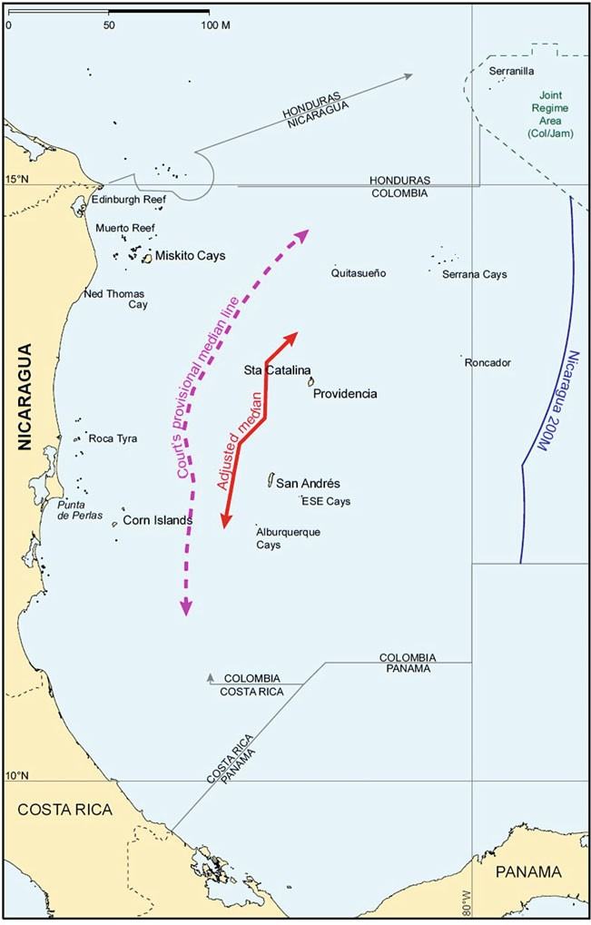
Fig. 7 The adjusted equidistance line

The Territorial and Maritime Dispute (Nicaragua v. Colombia).. . 135

in coastal lengths. The Court further reasoned that by cutting off Nicaragua from the areas east of the principal Colombian islands into which the Nicaraguan coast projects, such a boundary would fail to take into account the second relevant consideration: avoidance of a cut-off effect.
Taking proper account both of the disparity in coastal lengths and the need to avoid cutting either State off from the maritime spaces into which its coasts project, the ICJ determined that an equitable result which ‘gives proper weight to those relevant considerations is achieved by continuing the boundary line out to the line 200 nautical miles from the Nicaraguan baselines along lines of latitude.’⁷⁰
As illustrated on Fig. 8,⁷¹ the delimitation lines thus established run as follows. First, from the northernmost point of the simplified weighted line (point 1), which is located on the parallel passing through the northernmost point on a 12-nautical mile arc around Roncador Cay, the delimitation line follows the parallel of eastward latitude until it reaches the 200 nautical-mile limit from Nicaragua’s coastal baselines (endpoint A).
Second, from the southernmost point of the simplified weighted line (point 5), the line of delimitation runs in a south-east direction until it intersects with the 12 nautical-mile arc around Alburquerque Cay (point 6). It then follows that arc until it reaches the point of intersection with the parallel passing through the southernmost point on the arc (point 7). The boundary then follows that parallel eastward until it reaches the southernmost point of the 12 nautical-mile arc around East-Southeast Cay (point 8) and continues along that arc until its most eastward point (point 9). From that point, the boundary follows the parallel of latitude until it reaches the 200 nautical-mile limit from Nicaragua’s coast (endpoint B).
The way the Court drew the boundary left Quitasue~no and Serrana outside the corridor between two parallels of latitude that it established for Colombia. To have expanded the Colombian corridor northward, so as to encompass these features, would have been to allow small, isolated features to disproportionately affect the boundary. Accordingly, the Court concluded that the most equitable solution with respect to these features was to enclave them within a 12 nautical-mile territorial sea.
The resulting delimitation—consisting (in summary) of (1) an adjusted equidistance line in the west, whose endpoints in the north and south are connected by straight lines running along parallels of latitude to another north-south line 200 nautical miles from Nicaragua’s coast, and (2) 12 nautical-mile enclaves around Quitasuen~o and Serrana—represents a complex (and creative) solution to a complex (and unique) geographical situation. It can be viewed as an adjusted equidistance line (with several different adjustments in different parts of the relevant area), or as a combination of different methodologies: modified equidistance in the west, a corridor created by parallels of latitude in the north

⁷⁰Nicaragua v. Colombia (Merits), supra n. 8, p. 710, para 236.
⁷¹This figure corresponds to the sketch-map No. 11 depicted in the Court’s Judgment at p. 89.

136 L.H. Martin and Y.B. Parkhomenko
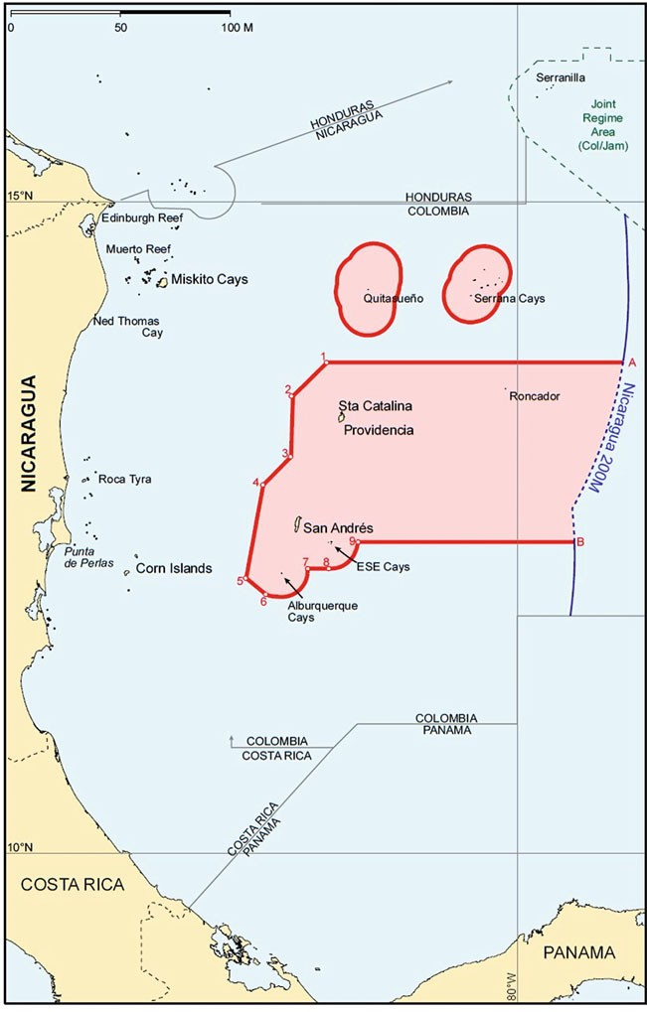
Fig. 8 The final delimitation

The Territorial and Maritime Dispute (Nicaragua v. Colombia).. . 137

and south, and enclavement of small islands determined to be too insignificant to otherwise affect the delimitation.
Regardless of how it is viewed methodologically, there is little doubt that the Court strove to achieve a solution that was equitable to both Parties, and that in the opinion of all 16 judges, including the distinguished ad hoc Judge appointed by Colombia itself, it succeeded in doing so.

    - Conducting a Disproportionality Test

In testing for disproportionality, the Court has consistently stated that ‘it is not applying a principle of strict proportionality’⁷² because ‘maritime delimitation is not designed to produce a correlation between the lengths of the Parties’ relevant coasts and their respective shares of the relevant area.’⁷³ Instead, the task is ‘to check for a significant disproportionality’ in order to ‘to ensure that there is not a disproportion so gross as to “taint” the result and render it inequitable.’⁷⁴
The case law reflects that the ICJ and other tribunals have displayed considerable caution in the application of the disproportionality test. In Libya/Malta the ratio of relevant coasts was approximately 8:1, a figure almost identical to that in the present case (8.2:1). At the second stage of its analysis in that case, the Court found that this disparity required an adjustment of the provisional equidistance line in Libya’s favor. Although the Court did not calculate the precise division of shares of the relevant area resulting from its delimitation (arguably because of the diffi- culty of determining the limits of the relevant area due to the overlapping interests of third States), nonetheless it is clear that the resulting maritime areas of Libya and Malta did not approach a ratio of 8:1; although Libya’s share of the area delimited was substantially increased from what it would have been had the boundary followed the provisional equidistance line, it was considerably less than eight times as large as the area received by Malta.⁷⁵
Similarly in Jan Mayen, where the ratio of relevant coasts was approximately 9:1 in Denmark’s favor and led the Court to shift the provisional equidistance line, the delimitation produced by the Court divided the relevant area in a manner that gave Denmark an advantage of approximately 2.7:1; that is, although Greenland’s relevant coast was nine times longer than Jan Mayen’s, Greenland (Denmark) received only between two and three times more of the relevant area as Jan Mayen (Norway).⁷⁶
As regards Nicaragua and Colombia, the Court calculated that the delimitation it produced divided the relevant area as between the Parties in a ratio of

⁷²Nicaragua v. Colombia (Merits), supra n. 8, p. 715, para 240.
⁷³Ibid.
⁷⁴Ibid., p. 715, para 240 and p. 716, para 242.
⁷⁵Ibid., p. 717, para 245.
⁷⁶Ibid.

138 L.H. Martin and Y.B. Parkhomenko

approximately 3.44:1 in Nicaragua’s favor. This division was not as favorable to Nicaragua as the ratio of lengths of the parties’ relevant coasts but was close enough, in the Court’s opinion, so as not to be markedly disproportionate, and to thereby pass the disproportionality test. This conclusion was consistent with the Court’s prior rulings, especially in Libya/Malta and Jan Mayen. As a consequence, neither Party could justifiably complain about the result. It was an equitable solution, in conformity with the long line of maritime delimitation cases decided by the Court and other international tribunals.

4 Conclusions

The maritime boundary the ICJ unanimously established was a creative solution to a complex geographic situation. The result allowed the coasts of both States to produce their effects in terms of maritime entitlements in a reasonable and mutually balanced way. This is the equitable solution required by international law.
The Court’s legal pronouncements and delimitation methodology provide a valuable guidance for States as they seek to settle maritime boundary disputes in the Caribbean Sea and elsewhere. First, the Court reaffirmed that the UNCLOS provisions on delimitation of the EEZ and continental shelf reflect customary international law. These provisions will thus apply in delimitation among the all States, even those that are not parties to the Convention.
Second, the Court made clear that the three-step delimitation methodology is not to be applied mechanically; it is not a rigid exercise. It may not be appropriate in every case to begin with a provisional equidistance line. Moreover, starting with a provisional equidistance line does not preclude very substantial adjustment to, or shifting of, the provisional line when the circumstances so dictate. Nor does it preclude the use of other delimitation methods or a combination of such methods as long as it is necessary to achieve an equitable result.
Third, the decision in Nicaragua v. Colombia further underscored the dispositive role objective geographic factors play in delimitation. It was a substantial differ- ence in the lengths of the parties’ respective coastlines and an inequitable cut-off effect created by small islands that justified the Court’s adjustments of the provi- sional delimitation line to achieve an equitable solution. This is consistent with the modern trend discernable in all recent maritime delimitation cases in which the only factors found relevant to the maritime boundary delimitation were geographic in nature: the geomorphological instability of a coastline (Nicaragua v. Honduras), an inequitable cut-off effect caused by small off-shore insular features (Romania
v. Ukraine) and a markedly concave coastline (the Bay of Bengal cases).
Although the Court has not entirely ruled out the possibility that non-geographic factors, such as the conduct of the parties or equitable access to natural resources, might be relevant, it nonetheless made clear that such factors could be taken into account, if at all, only in highly exceptional circumstances. The Court also made

The Territorial and Maritime Dispute (Nicaragua v. Colombia).. . 139

clear that delimitations already effected in the area with third States do not constitute a relevant circumstance; such delimitations are res inter alios acta.
Fourth, the Court solidified the fundamental rule that emerged from the case law: if equidistance methodology is used, an island must be given full weight unless it has the effect of pushing the provisional equidistance line across, and in front of, another State’s coastal front, resulting in a cutoff of that State’s seaward projection. If the provisional equidistance line is distorted in this manner, the island may be discounted, given less than full weight in the delimitation or enclaved to avoid or abate an inequitable cut-off effect.

References

Bowett D (1993) Islands, rocks, reefs and low-tide elevations in maritime boundary delimitations.
In: Charney J, Alexander LM (eds) International maritime boundaries, vol I. Brill/Nijhoff Dundas C (2005) Regional reports: Middle America/The Caribbean. In: Colson DA, Smith RW
(eds) International maritime boundaries, vol V. Brill/Nijhoff
Freestone D, Schofield C (2015) The Caribbean Sea and Gulf of Mexico. In: Rothwell DR, Oude Elferink AG, Scott KN, Stephens T (eds) The Oxford handbook of the law of the sea. Oxford Nweihed KG (1996) Regional reports: Middle American and Caribbean maritime boundaries. In:
Charney J, Alexander LM (eds) International maritime boundaries, vol I. Brill/Nijhoff

Lawrence H. Martin is a Partner and the Deputy Chair of International Litigation and Arbitra- tion Department at Foley Hoag LLP.

Yuri B. Parkhomenko is an international dispute resolution lawyer in International Litigation and Arbitration Department at Foley Hoag LLP. The views and opinions expressed in this chapter are those of the authors and do not necessarily reflect the views and opinions of Foley Hoag LLP.

